



**SM6P07NI Digital Media Project**

**20% Report**

**2024-25 Autumn**

**Student Name: Kritan Chandra Shrestha**

**London Met ID: 22067395**

**College ID: NP01MM4A220078**

**External Supervisor: Saugat Basnet**

**Internal Supervisor Parwat Bhujel**

**Assignment Due Date: Wednesday, May 7, 2025**

**Assignment Submission Date: Wednesday, May 7, 2025**

**Word Count: 2376**

*I confirm that I understand my coursework needs to be submitted online via Google Classroom under the relevant module page before the deadline in order for my assignment to be accepted and marked. I am fully aware that late submissions will be treated as non-submission and a marks of zero will be awarded.*

# Turnitin Similarity Check

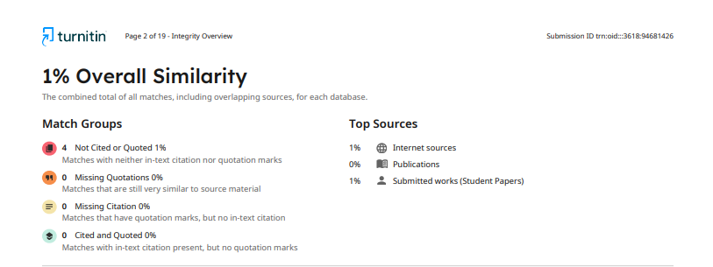

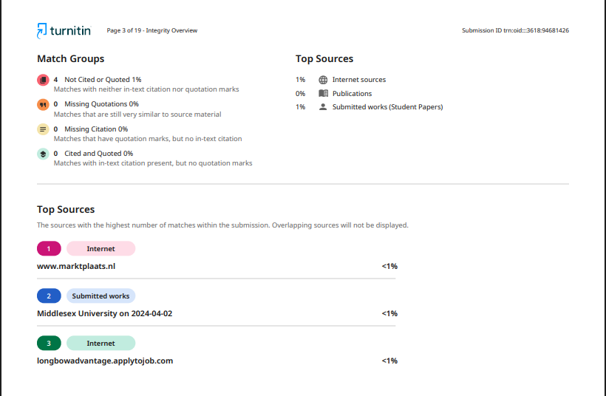

# Abstract

This project focuses on the design of the UI/UX for AgriBaato, a digital platform that connects Nepalese farmers, traders, and agribusiness. The design method for creating a responsive, user-friendly interface for both the "AgriBaato Corporate" and "AgriBaato Farmer" platforms involve extensive planning, UI trend research, competitor analysis, and testing. The documentation includes information on the project's aim, target audience, tools and technologies used, planning and development stages, production phases, user testing feedback, and final product evaluation. The goal was to produce a visually appealing and effective design that meets the needs of users while also improving agricultural accessibility.

**Contents**

Turnitin Similarity Check 2

Abstract 3

Table of Figures 5

1 Introduction 1

1.1 Topic 2

1.2 Area of Research 3

2 Aims of Project 4

3 Target Audience 5

4 Product Research 6

4.1 GeoKrishi 6

4.2 Agri Webb 8

5 Technologies Employed 10

6 Project Plan 11

7 Production Phases 13

7.1 Planning and Research 13

7.2 Wireframing 14

7.3 Low Fidelity 23

7.4 Graphic Designing 32

7.5 High Fidelity Design 34

7.6 Prototyping 45

7.7 Testing and Optimization 46

8 Resources 47

9 User Testing & Findings 49

9.1 Survey Results 50

10 Conclusion 61

11 References 62

12 Appendix 63

# Table of Figures

Figure 1 Agribaato Logo 2

Figure 2 GeoKrishi Website 6

Figure 3 GeoKrishi Website 2 7

Figure 4 Agri Webb Website 8

Figure 5 Agri Webb Website 2 9

Figure 6 Google Forms 10

Figure 7 Canva 10

Figure 8 Figma 10

Figure 9 Previous Gantt Chart 11

Figure 10 Updated Gantt Chart 12

Figure 11 Home Page Wireframe 14

Figure 12 Marketplace Wireframe 15

Figure 13 marketplace 2 Wireframe 16

Figure 14 post a bid Wireframe 17

Figure 15 marketprices Wireframe 18

Figure 16 bidding Wireframe 19

Figure 17 resources Wireframe 20

Figure 18 about us Wireframe 21

Figure 19 user dashboard wireframe 22

Figure 20 homepage Low Fidelity 23

Figure 21 marketplace Low Fidelity 24

Figure 22 bidding Low Fidelity 25

Figure 23 marketplace Low Fidelity 26

Figure 24 post a bid Low Fidelity 27

Figure 25 marketprices Low Fidelity 28

Figure 26 resources Low Fidelity 29

Figure 27 about us Low Fidelity 30

Figure 28 signin Low Fidelity 31

Figure 29 Graphic Designing 32

Figure 30 Graphic Designing 33

Figure 31 Graphic Designing 33

Figure 32 homepage High Fidelity 34

Figure 33 marketplace High Fidelity 35

Figure 34 marketplace High Fidelity 36

Figure 35 bidding High Fidelity 37

Figure 36 bidding sellerview High Fidelity 38

Figure 37 post a bid High Fidelity 39

Figure 38 marketprices High Fidelity 40

Figure 39 resources High Fidelity 41

Figure 40 aboutus High Fidelity 42

Figure 41 signin High Fidelity 43

Figure 42 user dashboard High Fidelity 44

Figure 43 Prototyping 45

Figure 44 Prototyping 2 45

Figure 45 Optimization 46

Figure 46 Optimization 2 46

Figure 47 Lenovo Legion 5 Pro 47

Figure 48 NVIDIA GeForce RTX 3060 47

Figure 49Survey Results 50

Figure 50 Questionnaire1 50

Figure 51Questionnaire2 51

Figure 52 Questionnaire 3 51

Figure 53 Questionnaire 4 52

Figure 54 Questionnaire 5 52

Figure 55 Questionnaire 7 53

Figure 56 Questionnaire 9 54

Figure 57 Questionnaire 11 55

Figure 58 Questionnaire 13 56

Figure 59 Questionnaire 15 57

Figure 60 Questionnaire 17 58

Figure 61 Questionnaire17 58

Figure 62 Questionnaire 18 59

Figure 63 Questionnaire 19 59

Figure 64 Questionnaire 20 60

# Introduction

This course covers the complete UI/UX design process for AgriBaato, a digital platform that aims to simplify and facilitate agricultural transactions in Nepal. This platform attempts to bring together farmers, merchants, cooperatives, and agribusinesses into a cohesive ecosystem that allows for real-time market pricing, bidding systems, and marketplace collaboration. The documentation describes each stage of the design process, beginning with the topic and study area selection, then establishing user personas, identifying key objectives, and doing extensive product and competition analysis. It also includes the technology used, the planning and production phases, the creation of wireframes and prototypes, and usability testing and assessment. This program promotes a user-centered design philosophy, with a focus on navigational simplicity, accessibility, and clear service communication. The report includes comments from real users to help modify the final product and ensure that it is functional and meets user needs and expectations.

## Topic

The topic of this project is AgriBaato – A UI/UX Design for a Digital Agricultural Platform in Nepal.

This project aims to create a user-friendly and interactive digital platform to improve the agricultural trading experience for both farmers and agribusinesses in Nepal. The platform is separated into two major interfaces: AgriBaato Farmer, which allows farmers to post products, monitor real-time prices, and connect with buyers, and AgriBaato Corporate, which allows cooperatives and merchants to handle bids, explore the marketplace, and access agricultural resources. Extensive research, planning, and testing were conducted during the design process to guarantee that the final product is both functional and accessible to the intended customers.



Figure 1 Agribaato Logo

## Area of Research

Here’s a more detailed expansion on each research area:

**User Interface Design Trends**:

Current UI design trends, including visual features like icons, buttons, and micro-interactions, can be researched to assist in developing a modern and intuitive interface. Color themes like nature-inspired or colorful tones complement AgriBaato's agricultural focus while taking color psychology into account to improve user experience. Typography selections, such as sans-serif fonts for readability and aesthetic appeal, will provide clarity and structure, resulting in a polished and accessible design.

**Competitor Analysis**:

Analyzing agricultural rivals can aid in the identification of industry standards, user preferences, and design trends. By analyzing rivals' strengths and shortcomings, AgriBaato may provide unique features that set it apart, hence enhancing usability and functionality. Studying successful platforms' best practices provides vital insights into efficient UI/UX design, ensuring that AgriBaato stands out while providing an intuitive and competitive user experience.

**Responsive and Interactive Designs**:

A flexible design guarantees that AgriBaato's platform adapts smoothly to all screen sizes, enhancing accessibility across devices such as smartphones, tablets, and computers, which is especially significant in rural areas. Interactive components, such as real-time market price updates and dynamic product listings, can help users interact and improve their experience. The design, which focuses on straightforward navigation and simple job flows, will make it easier for users to interact with the site, increasing engagement and happiness.

# Aims of Project

The aim of this project is to create a practical, responsive, and visually appealing user interface for AgriBaato, an agricultural platform that serves both farmers and corporate users in Nepal. The design will prioritize improving the user experience by incorporating modern UI/UX principles such as straightforward navigation, accessible layouts, and interactive components customized to the demands of various user groups. The goal is to develop an intuitive platform that streamlines agricultural transactions, promotes market pricing transparency, supports fair bidding procedures, and improves buyer-seller communication. By solving usability and accessibility issues, the project hopes to empower users in both rural and urban settings, resulting in more efficient and inclusive digital agriculture.

# Target Audience

AgriBaato's core target audience consists of Nepalese farmers, traders, cooperatives, and agribusiness experts, who are mostly located in rural and semi-urban areas of Nepal. The age range is 25 to 55 years, and this demographic is particularly active in agriculture and trading. The website is gender-inclusive, catering to both male and female users while embracing women's rising participation in agricultural and agribusiness. The ethnicity of users is broad, reflecting Nepal's multi-ethnic population, with a focus on assisting local communities across provinces.

These specific audiences are being targeted because they have a direct engagement in agriculture production, trading, and supply chain operations. Farmers need real-time market prices and expanded market prospects, whereas corporate customers need tools for transparent bidding and networking with service providers. The UI/UX design aspires to be simple, intuitive, and accessible, considering varying degrees of digital literacy and providing inclusion for people with less technical knowledge. This guarantees that the platform is useful, user-friendly, and relevant to the individuals it is meant to serve.

# Product Research

## GeoKrishi

Focus: An agricultural decision-support tool for Nepali farmers (planning, weather, and input tracking).

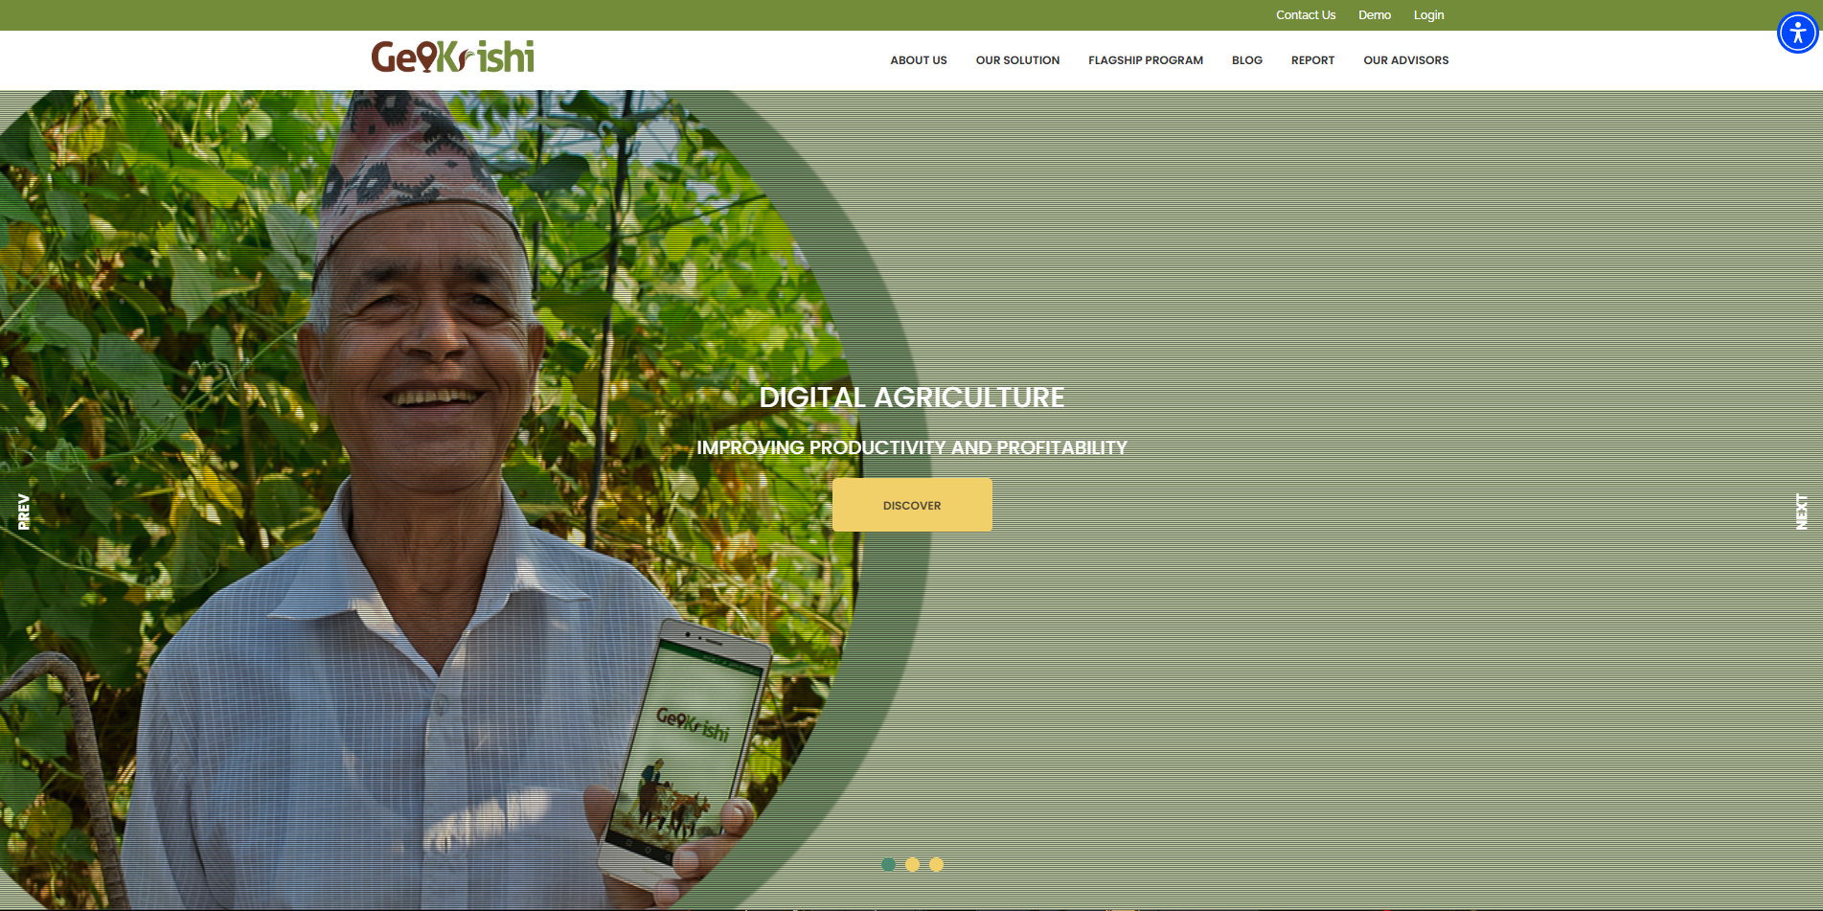

Figure 2 GeoKrishi Website

Good Points:

Expert knowledge of all aspects of Nepal's agricultural sectors.

Employs local experts plus temporary scheduling with climate predictions.

Our platform communicates exclusively in Nepali language.

Bad Points:

Limited trading options, largely for informational purposes.   
  
The website's design does not accommodate small displays.   
  
The images are out of date, and the iconography is inconsistent.

Analysis:

GeoKrishi helps farmers through advisories without providing them with opportunities to connect to markets. The system concentrates on farm practices instead of marketplace activity.

Implementation for AgriBaato:

Join province or district filtering data to help users explore local information.

Take inspiration from crop calendars today so we can add them later as an optional feature.

Place modern visual design first and build trading tools starting from buying and selling.

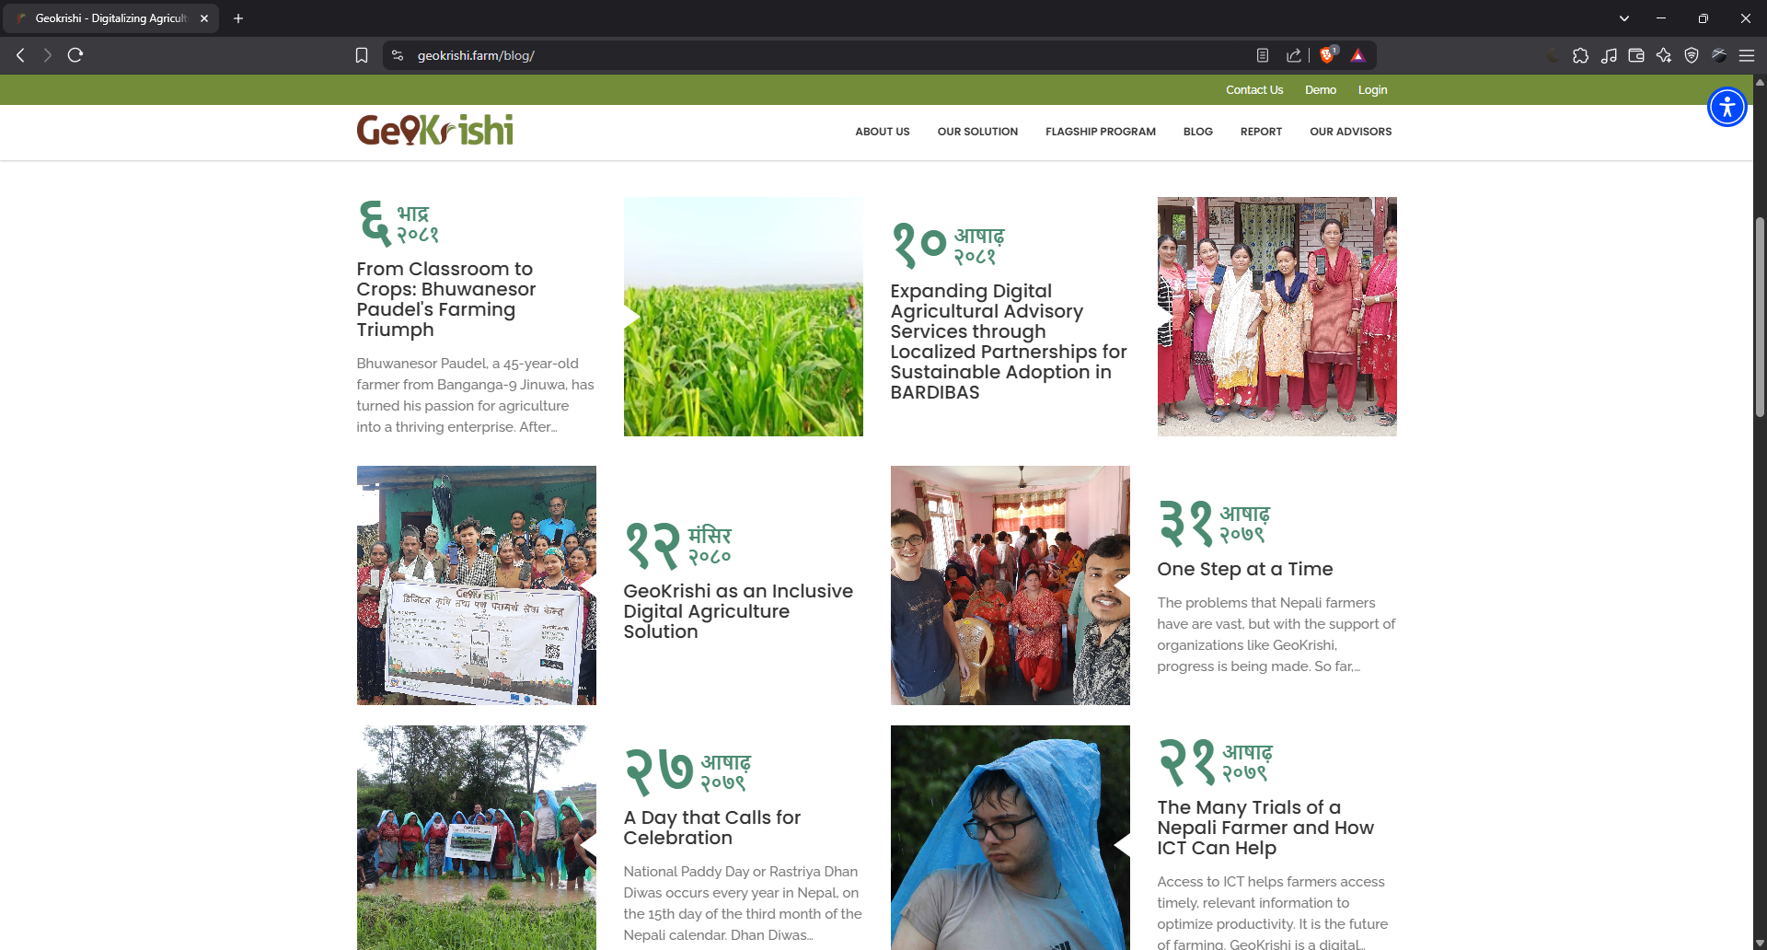

Figure 3 GeoKrishi Website 2

## Agri Webb

Focus: Commercial farms can benefit from digital farm and livestock management software.

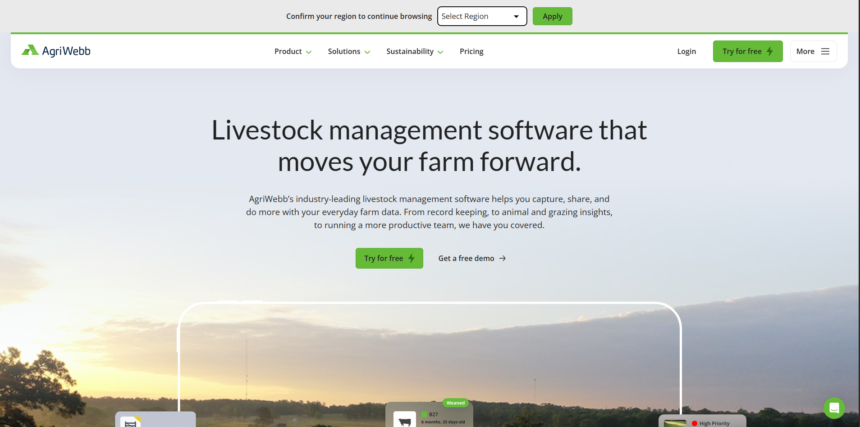

Figure 4 Agri Webb Website

Good Points:

Excellent data management dashboards.

It allows you to capture data offline.

Let’s keep detailed farm operations in a simple daily journal.

Bad Points:

Too complex for small farmers.

The system prioritizes livestock information which is not beneficial for farmers who only grow crops.

Market leaders designed their platform primarily for enterprise use, but it remains beyond rural users who lack technical training.

Analysis:

Agri Webb’s powerful functions do not match the needs of crop-farming small farmers in Nepal. The registrar on data will supply information for future visualization needs.

Implementation for AgriBaato:

In future releases we will build a lightweight dashboard to present essential farm data including price records, sales performance and winning auctions.

Design a simple interface that shows visual information to prevent an overloaded display of data.

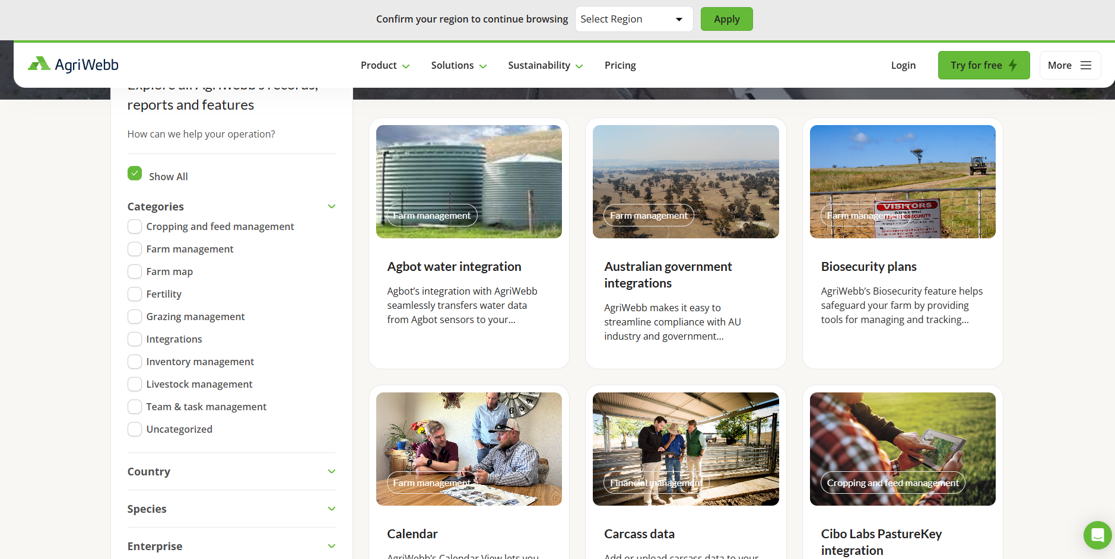

Figure 5 Agri Webb Website 2

# Technologies Employed

To ensure a professional and user-centered conclusion, the AgriBaato UI/UX design project was developed using a variety of software tools and approaches.

Figma was the primary tool for developing low-fidelity wireframes, high-fidelity mockups, and interactive prototypes. It provided real-time collaboration, design consistency, and simple iteration throughout the design process.

To maintain visual coherence and correspond with the agricultural theme, a carefully chosen color palette was used, with an emphasis on earthy and natural tones that represent trust and progress. Canva stock photos were used to increase visual appeal and provide relevant, high-quality graphics to supplement the content.

Furthermore, Google Forms was used to develop and distribute user questionnaires, enabling for the collection of user comments and insights that influenced design choices. These technologies combined to create a visually beautiful, functional, and user-friendly design.



Figure 6 Google Forms

Figure 7 Canva



Figure 8 Figma

# Project Plan

The AgriBaato UI/UX project was originally intended to build a client-based product; however, due to the client's inability to sign the proposal, the project was shifted to focus purely on design without a genuine client. The initial timeframe comprised steps such as proposal approval, research, wireframing, feedback collecting, and prototype creation, with the goal of completing all phases by mid-semester.

A low-fidelity prototype in Figma was produced for early testing, demonstrating essential user flows for both the AgriBaato Corporate and Farmer platforms. It consisted of pages such as the homepage, market price dashboard, and bidding part, which were tested with peers and instructors. The high-fidelity prototype was improved based on user feedback, including clearer navigation, better visuals, and increased responsiveness.  
  
Testing was initially scheduled to be finished by Week 6, however due to changes in project objectives and a higher emphasis on design quality, the final design was completed by Week 24. To provide a more intuitive and user-friendly product, key enhancements included a refined navigation flow, enhanced UI components, and consistent visual styling.

These is the Coursework 1 Gantt Chart.

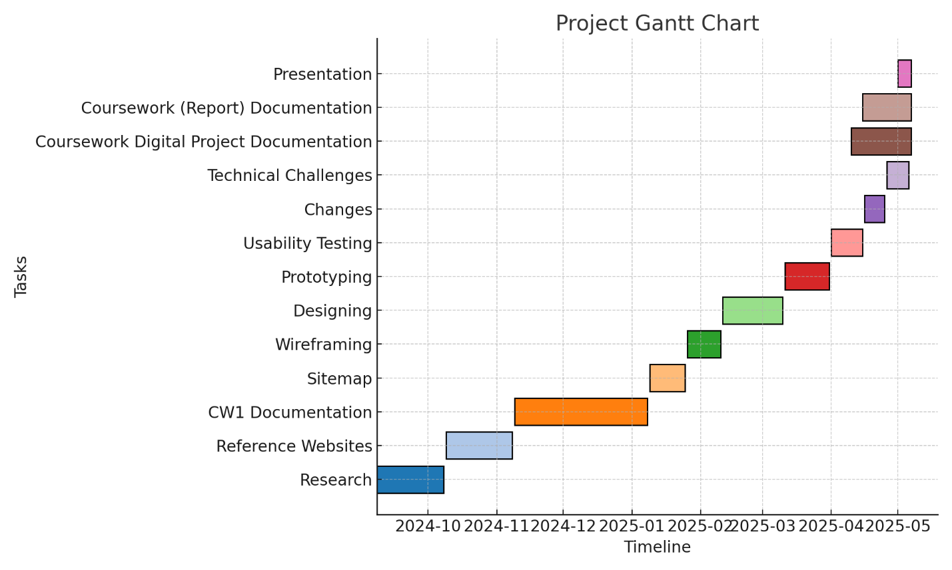

Figure 9 Previous Gantt Chart

Updated Gantt Chart

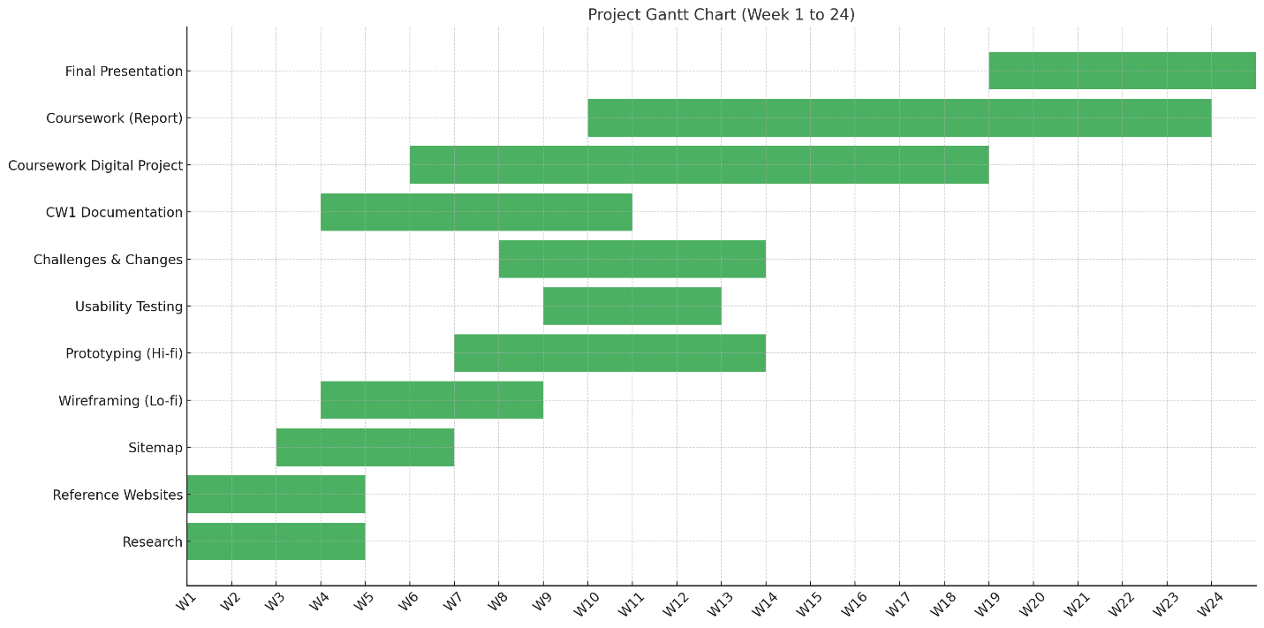

Figure 10 Updated Gantt Chart

# Production Phases

## Planning and Research

This phase included background study on UI/UX design trends, color schemes, typography, and responsive design. Competitor analysis assisted in identifying strengths and weaknesses in similar agricultural platforms. The target audience was selected, and project objectives were formed based on user requirements.

## Wireframing

Figma was used to develop initial sketches and digital wireframes for essential sections such as the homepage, market dashboard, and product listing. These wireframes lacked visuals and focused on layout, content organization, and user flow only.

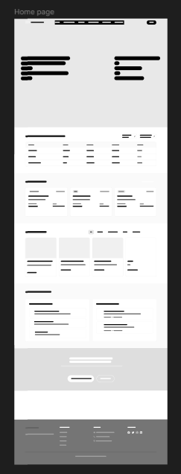

Figure 11 Home Page Wireframe

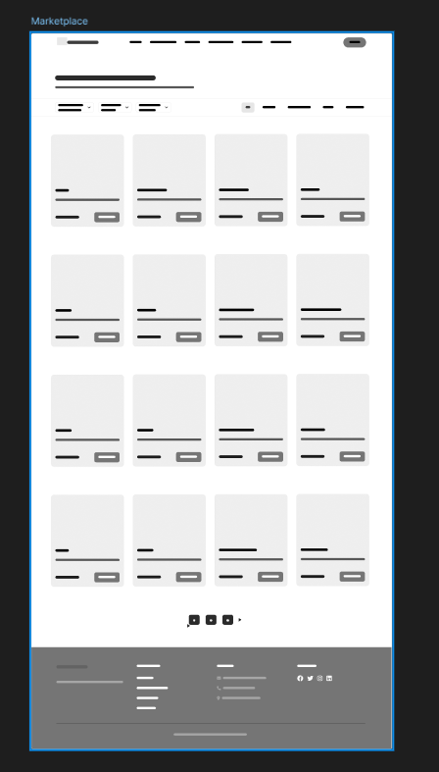

Figure 12 Marketplace Wireframe

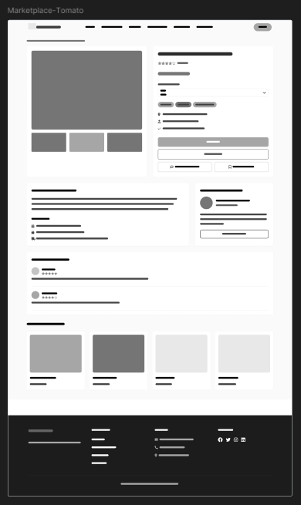

Figure 13 marketplace 2 Wireframe

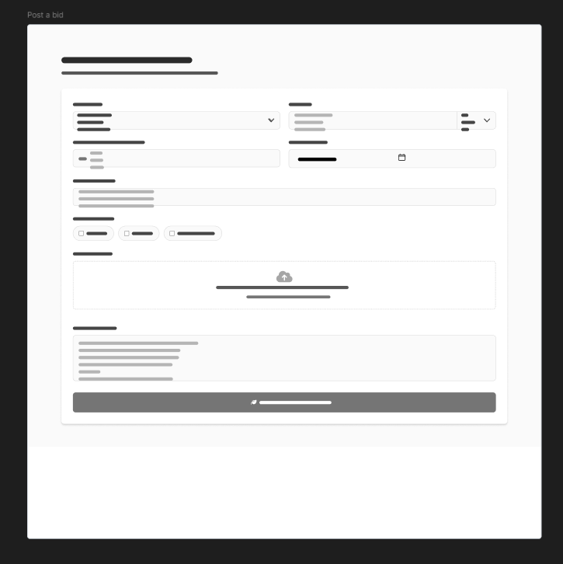

Figure 14 post a bid Wireframe

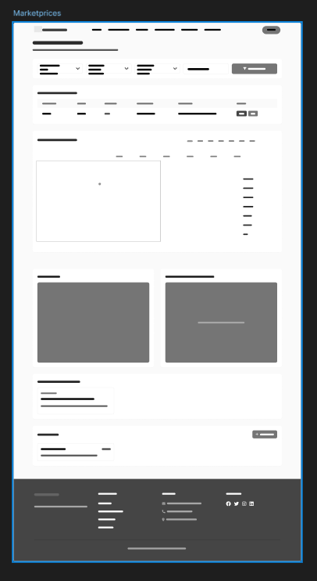

Figure 15 marketprices Wireframe

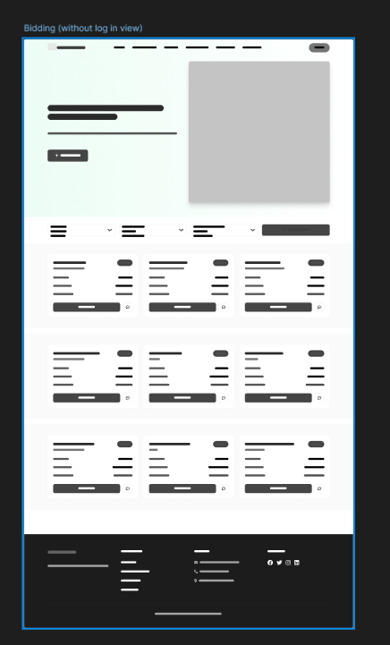

Figure 16 bidding Wireframe

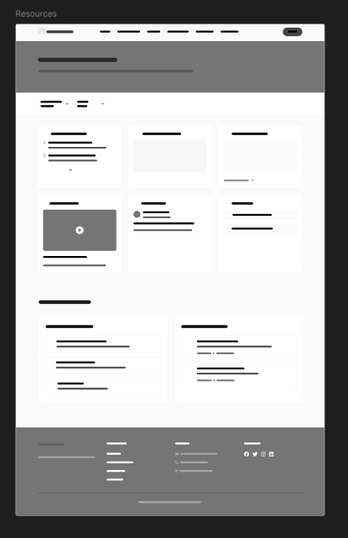

Figure 17 resources Wireframe

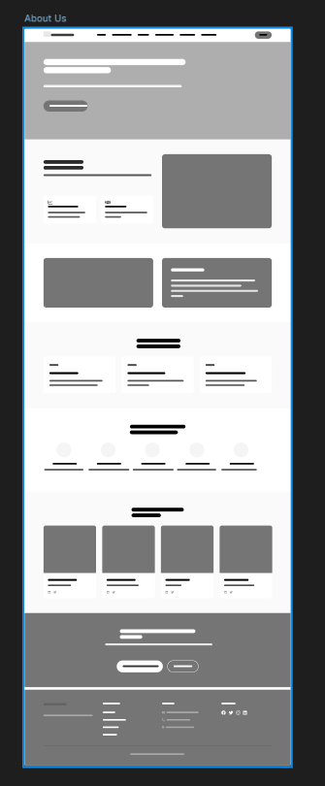

Figure 18 about us Wireframe

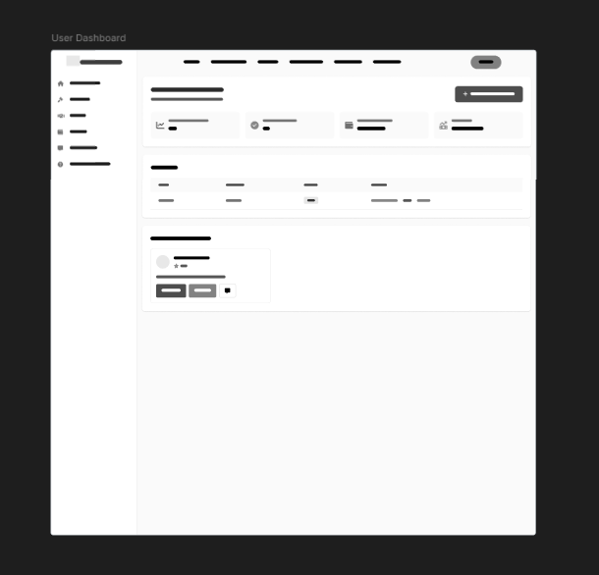

Figure 19 user dashboard wireframe

## Low Fidelity

Low-fidelity prototypes in Figma were created to demonstrate basic interactions and layout positioning. These comprised simple placeholders and were used to solicit input from instructors and peers for preliminary usability enhancements.

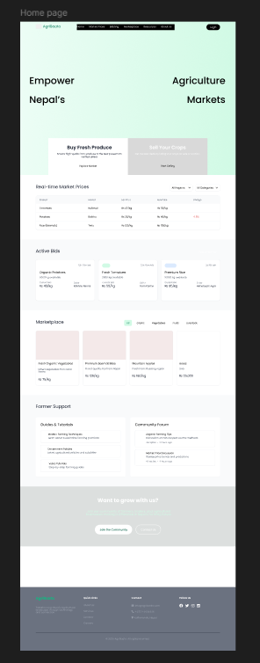

Figure 20 homepage Low Fidelity

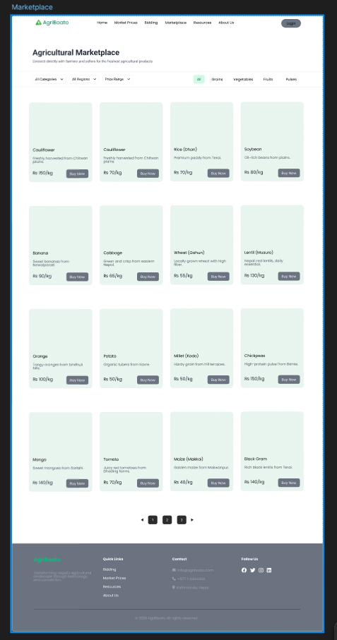

Figure 21 marketplace Low Fidelity

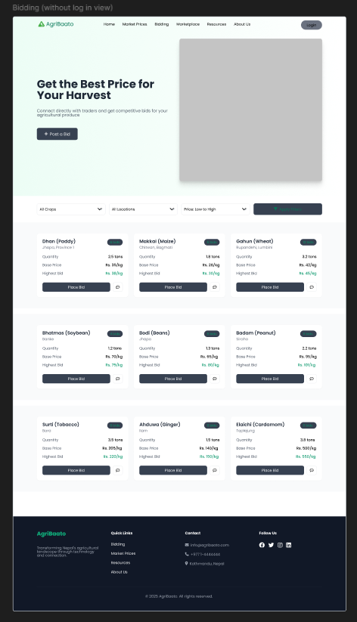

Figure 22 bidding Low Fidelity

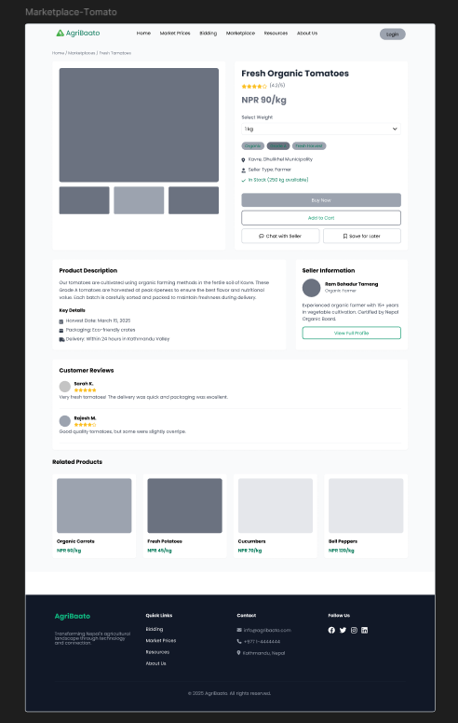

Figure 23 marketplace Low Fidelity

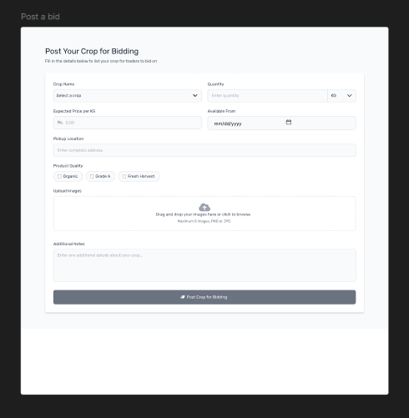

Figure 24 post a bid Low Fidelity

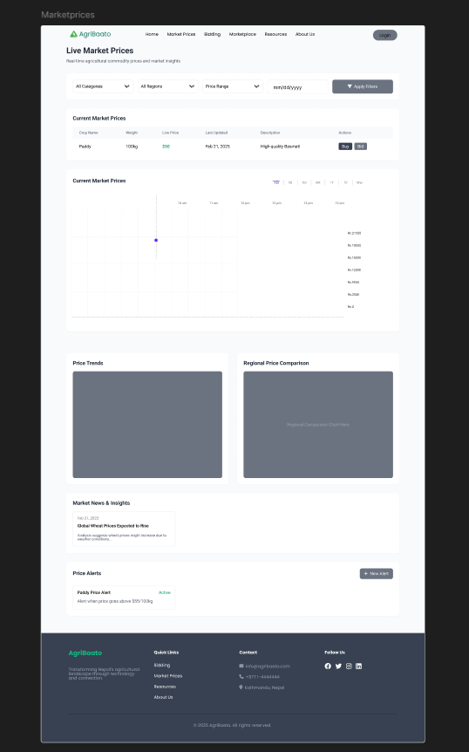

Figure 25 marketprices Low Fidelity

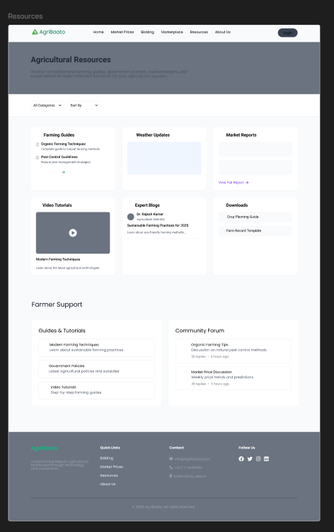

Figure 26 resources Low Fidelity

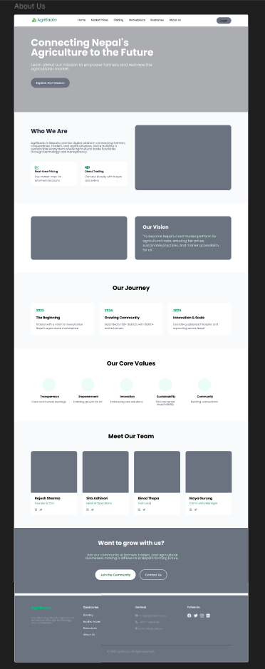

Figure 27 about us Low Fidelity

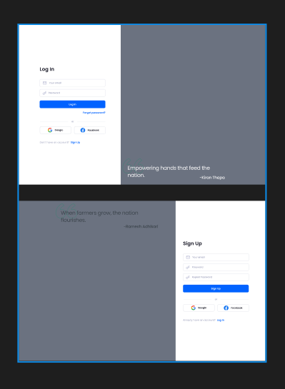

Figure 28 signin Low Fidelity

## Graphic Designing

Visual elements such as graph, banners, and backgrounds were created. A consistent color palette inspired by agriculture (green, brown, and earthy tones) was applied, and Canva was used for selecting relevant stock images that reflect Nepalese farming culture.



Figure 29 Graphic Designing

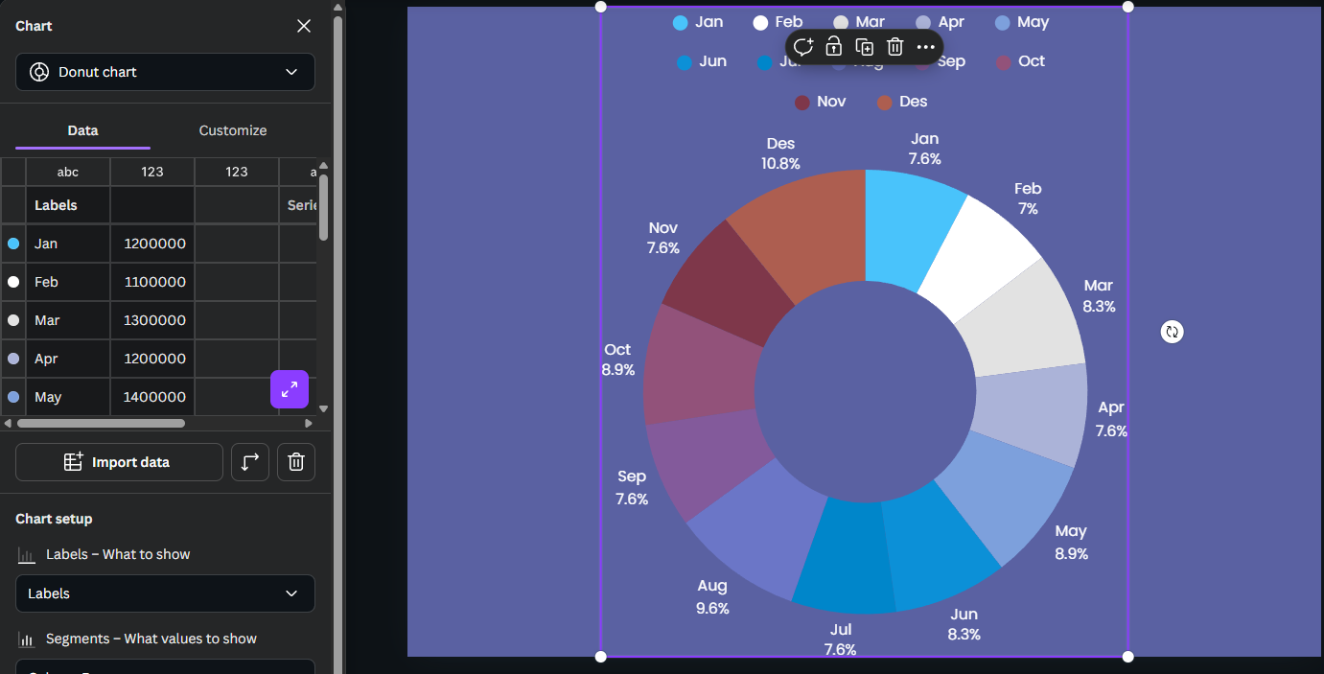

Figure 30 Graphic Designing

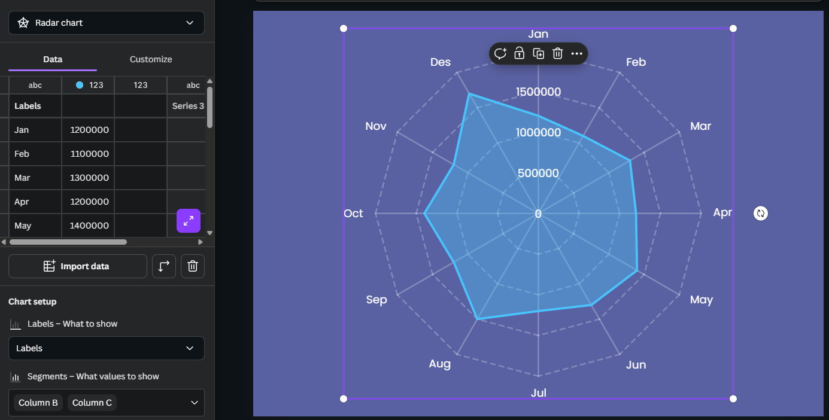

Figure 31 Graphic Designing

## High Fidelity Design

Figma was used to develop refined versions of each page, including final font, graphics, space, and UI elements. The pages appeared more like a real program, and they adhered to modern UI/UX standards for responsiveness and clarity.

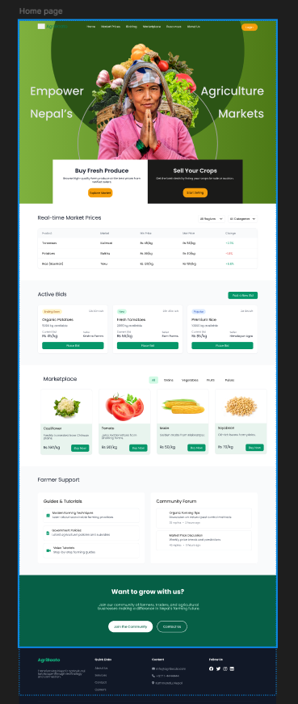

Figure 32 homepage High Fidelity

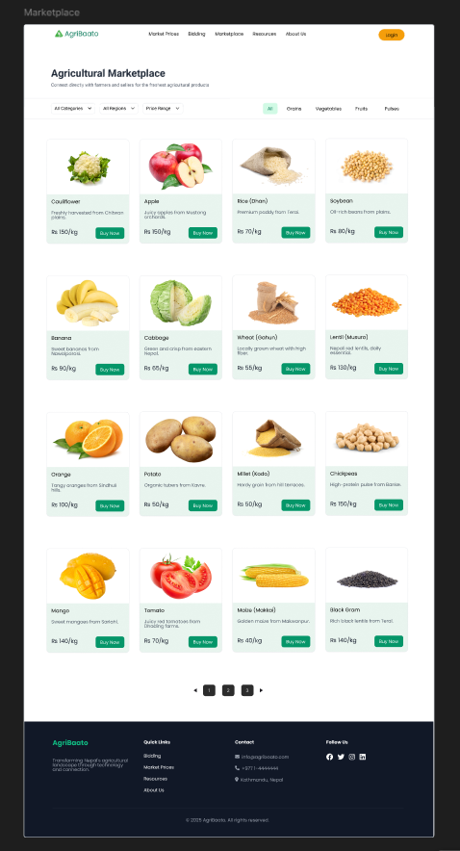

Figure 33 marketplace High Fidelity

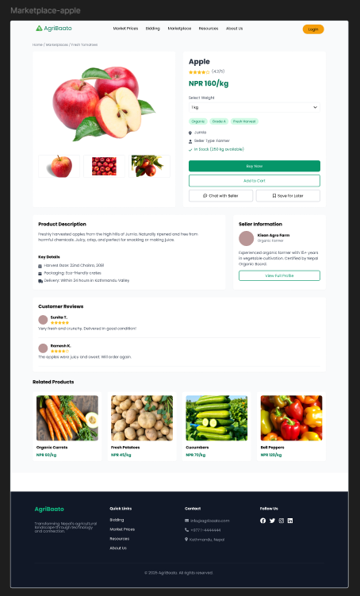

Figure 34 marketplace High Fidelity

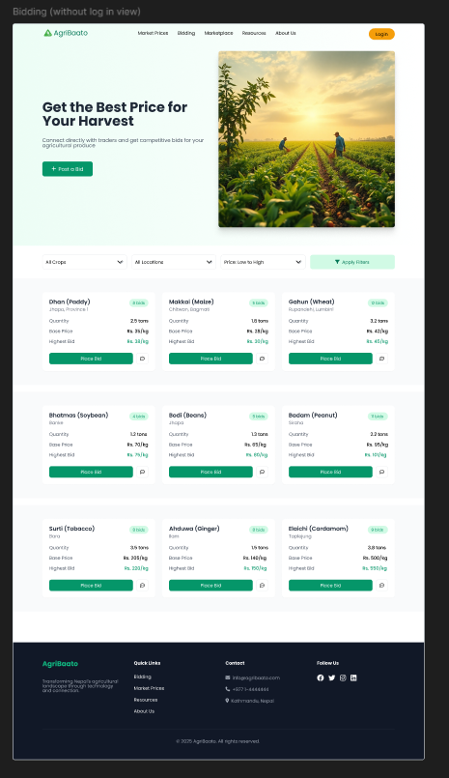

Figure 35 bidding High Fidelity

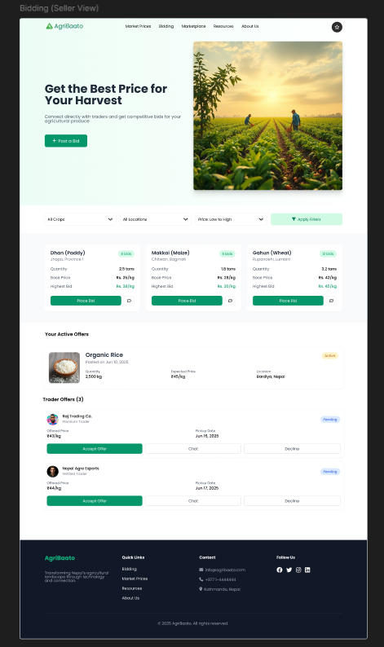

Figure 36 bidding sellerview High Fidelity

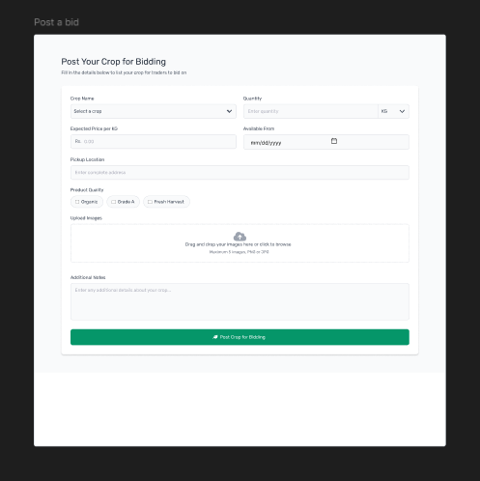

Figure 37 post a bid High Fidelity

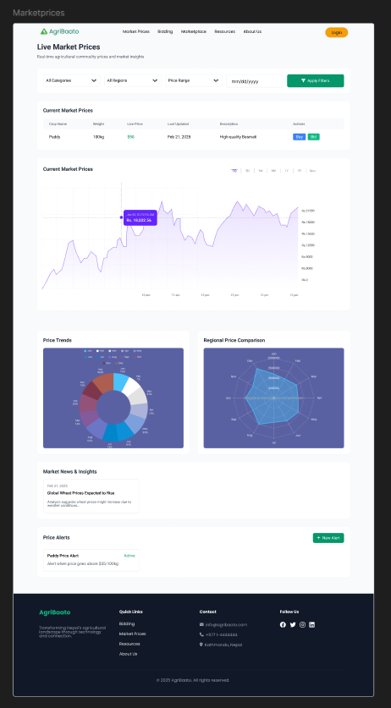

Figure 38 marketprices High Fidelity

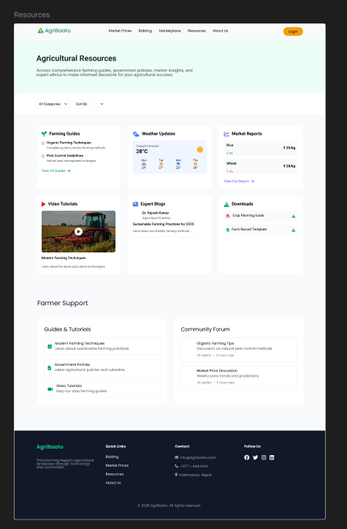

Figure 39 resources High Fidelity

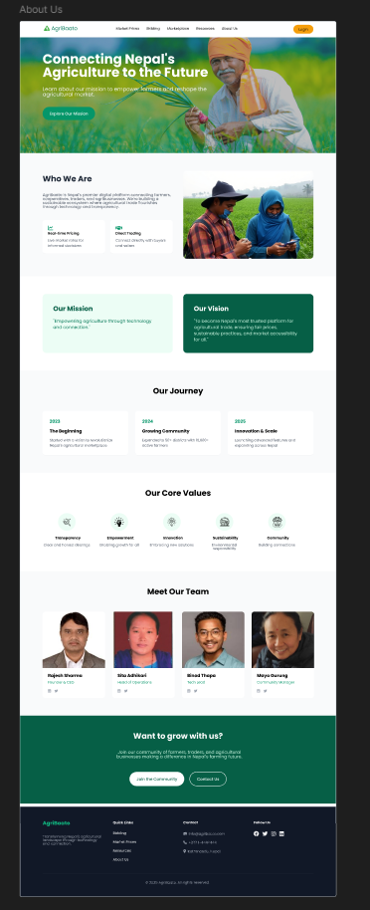

Figure 40 aboutus High Fidelity

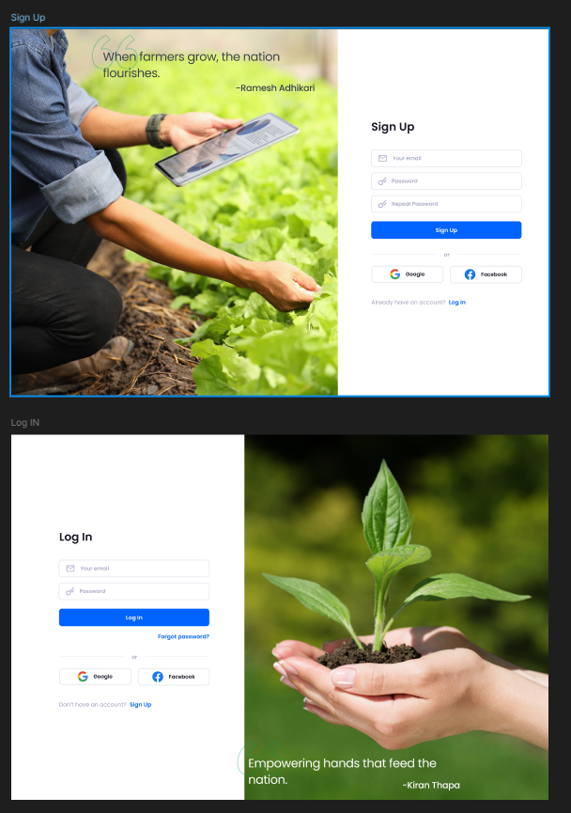

Figure 41 signin High Fidelity

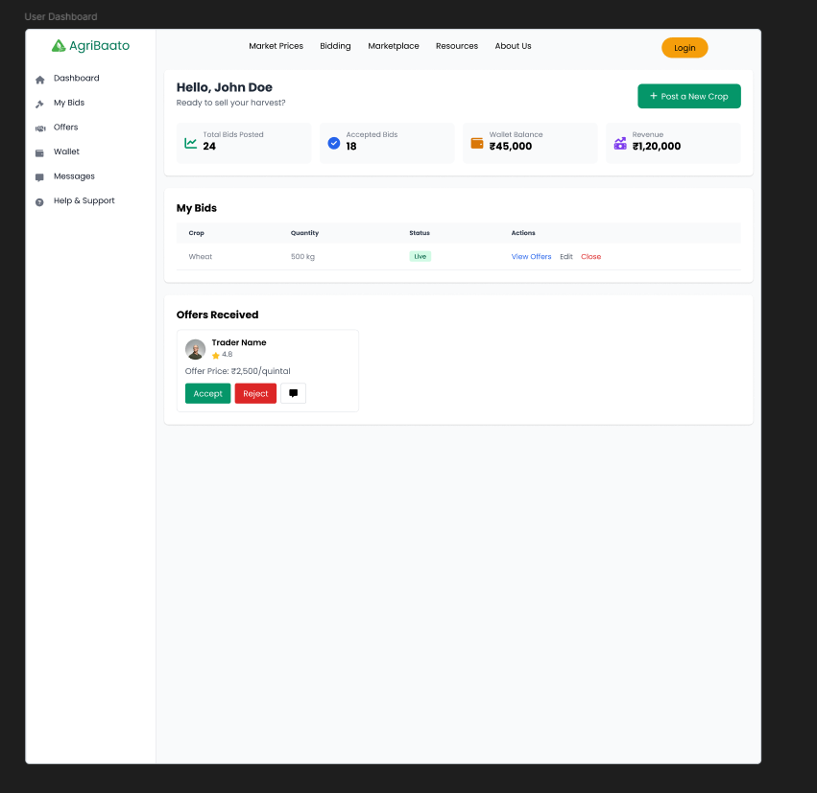

Figure 42 user dashboard High Fidelity

## Prototyping

Figma was used to construct an interactive prototype of user journeys across both platforms (Corporate and Farmer). To imitate actual usage, key tasks such as viewing market pricing, bidding, and uploading products were made clickable.

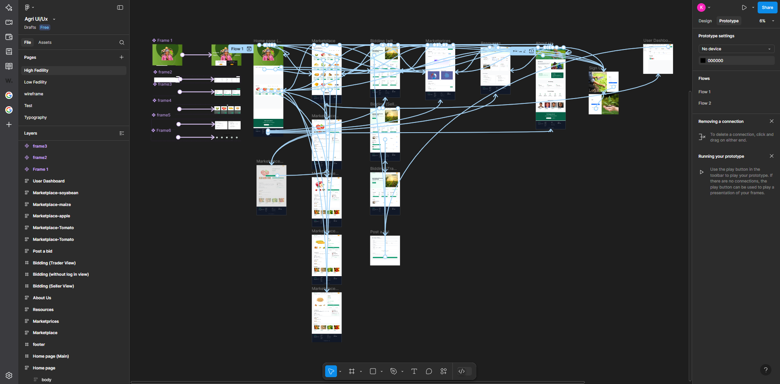

Figure 43 Prototyping

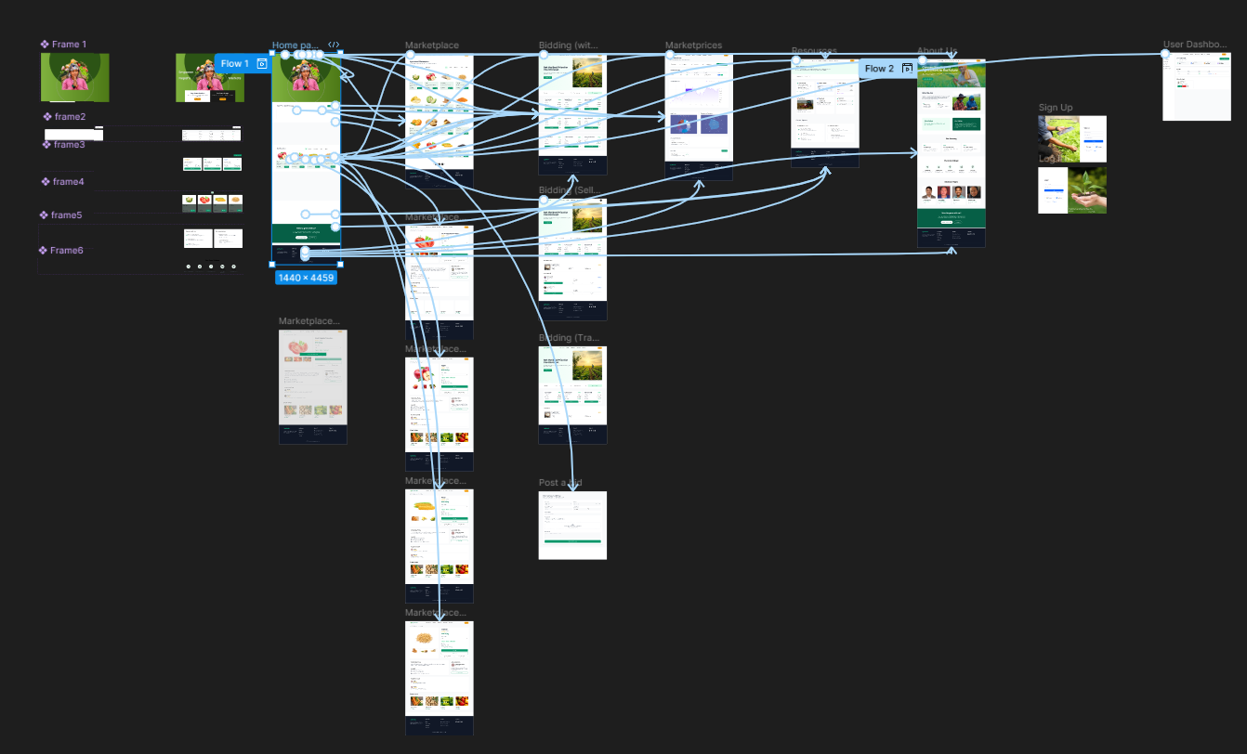

Figure 44 Prototyping 2

## Testing and Optimization

A small number of users and tutors tested the prototype for feedback. As a result, UI components were modified, navigation flow was streamlined, and minor visual concerns were addressed. The final version was finished in Week 24, ensuring that the product was both user-friendly and visually coherent.

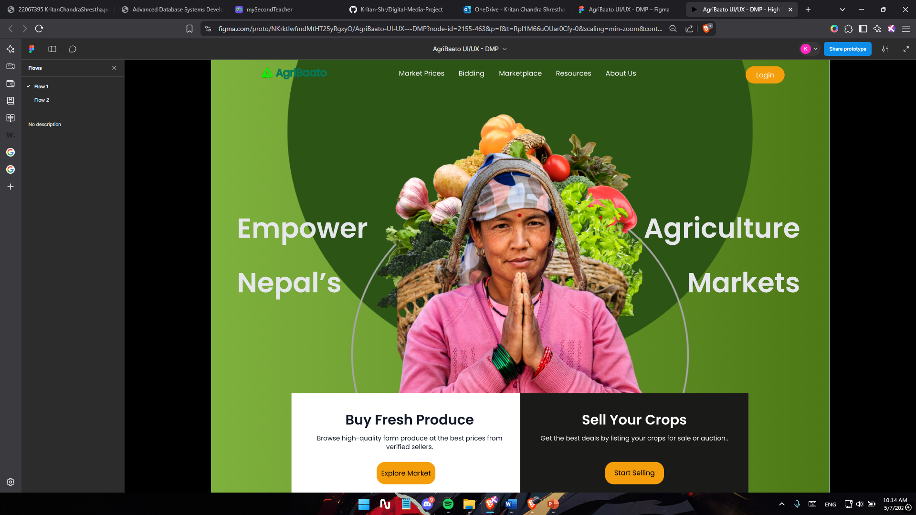

Figure 45 Optimization

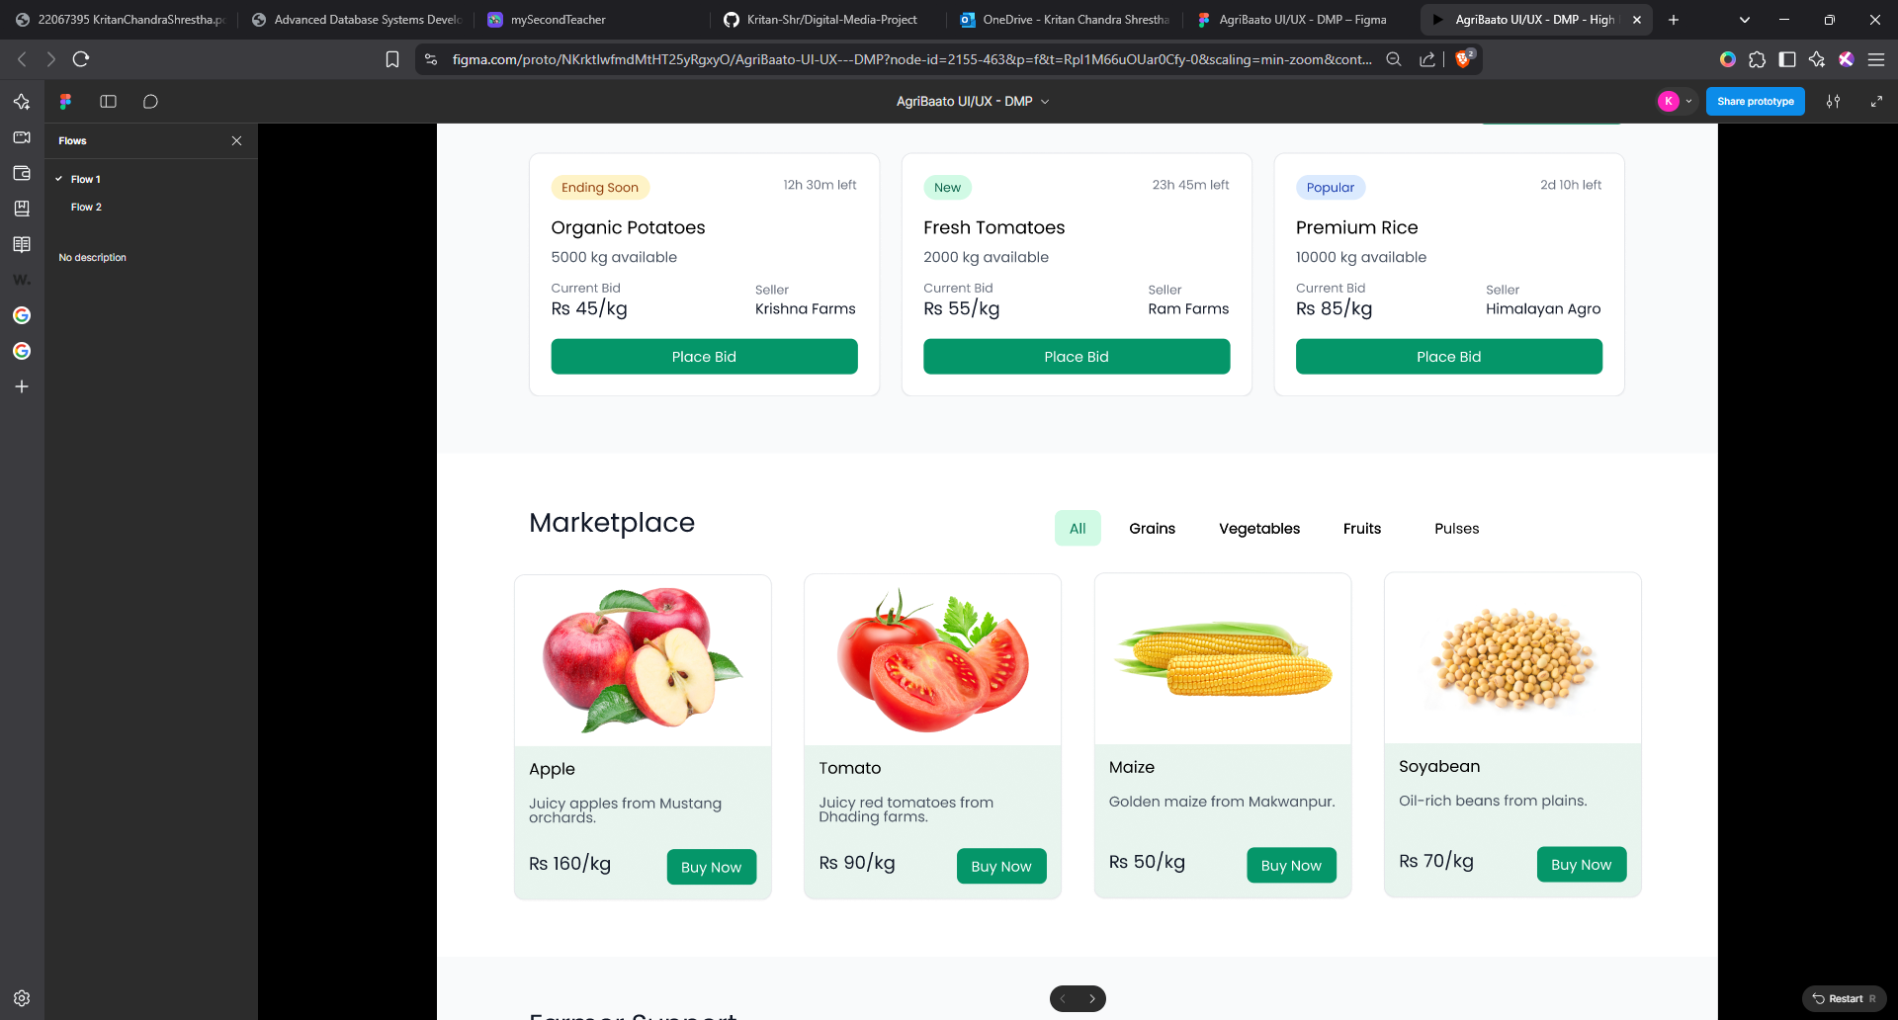

Figure 46 Optimization 2

# Resources

User Inface design and prototyping will be done in Figma. Image adjustments & stock footage from Canva.

Google forms will be used for usability testing.

Hardware specifications:

Lenovo Legion 5 Pro



Figure 47 Lenovo Legion 5 Pro

NVIDIA GeForce RTX 3060



Figure 48 NVIDIA GeForce RTX 3060

Processor: AMD Ryzen 7 6800H with Radeon Graphics



Installed RAM: 16 GB

Softwares:

• Figma

• Google Forms

• Canva

# User Testing & Findings

User Demographics: To better understand the target audience, we collected information on user type (farmer, trader, or general user), age group, and digital experience.  
  
Ease of Navigation: Determined whether users considered the platform's structure logical and easy to move between pages.  
  
Clarity of Purpose: Assessed how well users understood the platform's features, such as bidding and marketplace listings.  
  
Task Completion: We asked if users could easily complete tasks including submitting crops, placing bids, and viewing market prices.  
  
Visual Design and Branding: Obtained feedback on color, layout, typefaces, and overall visual appeal.  
  
Content Clarity: Determined whether text labels, buttons, and CTAs were clear and contextually relevant.

Functionality input: Gathered input on the usability and simplicity of important elements such as real-time price display and profile dashboard.  
  
Response and Performance: Provide feedback on design speed or responsiveness (mainly for post-development).  
  
Suggestions for Improvement: Provide open-ended input on prospective new features or upgrades.  
  
Overall Satisfaction: Finally, ask about the overall experience, user rating, and likely to use or recommend the platform.

## Survey Results

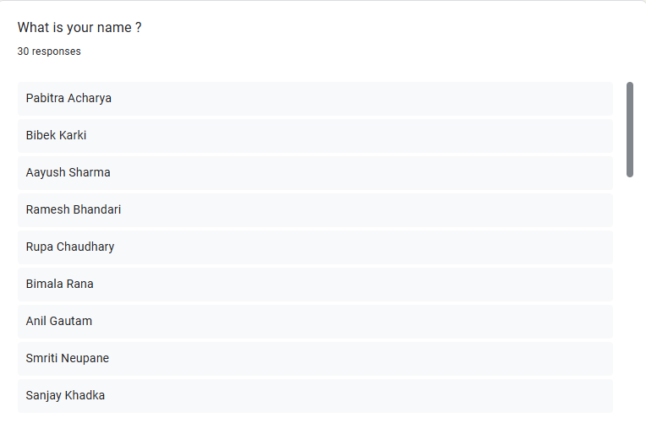

Figure 49Survey Results

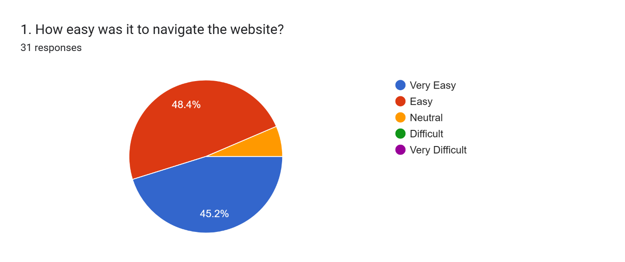

Figure 50 Questionnaire1

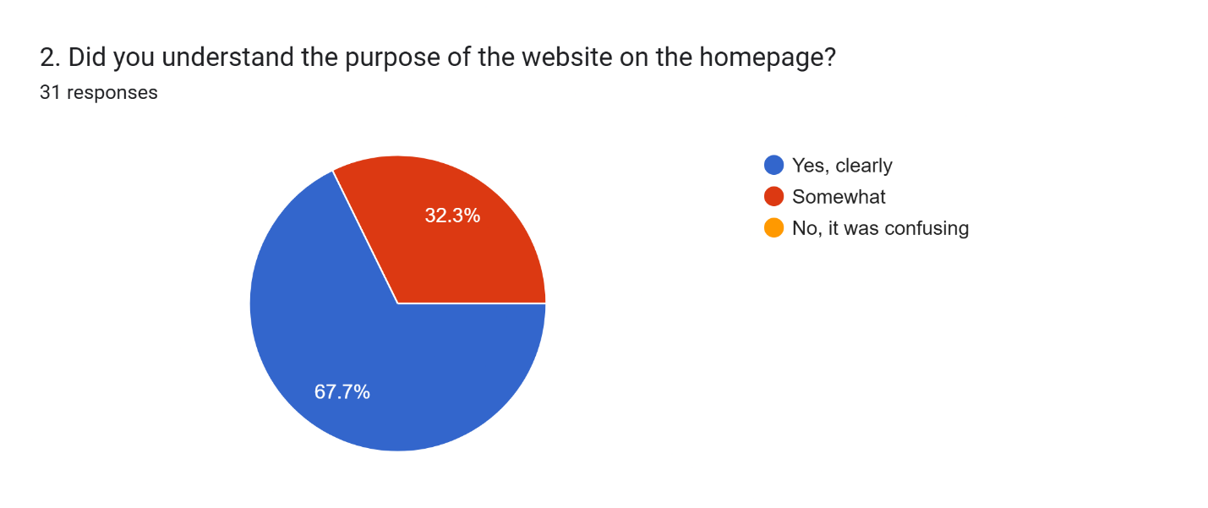

Figure 51Questionnaire2

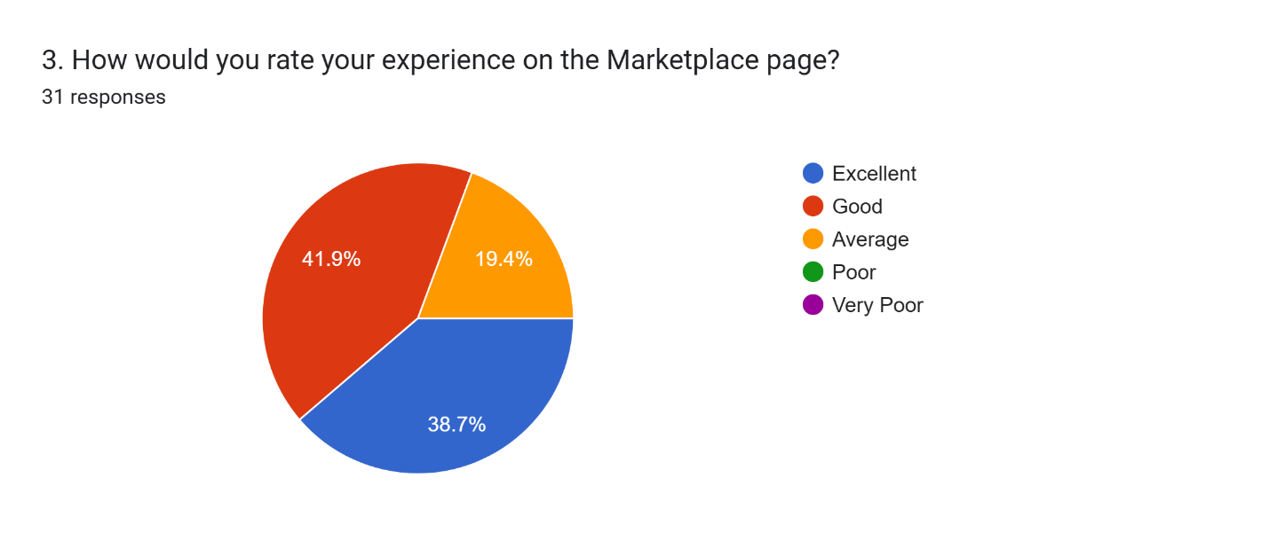

Figure 52 Questionnaire 3

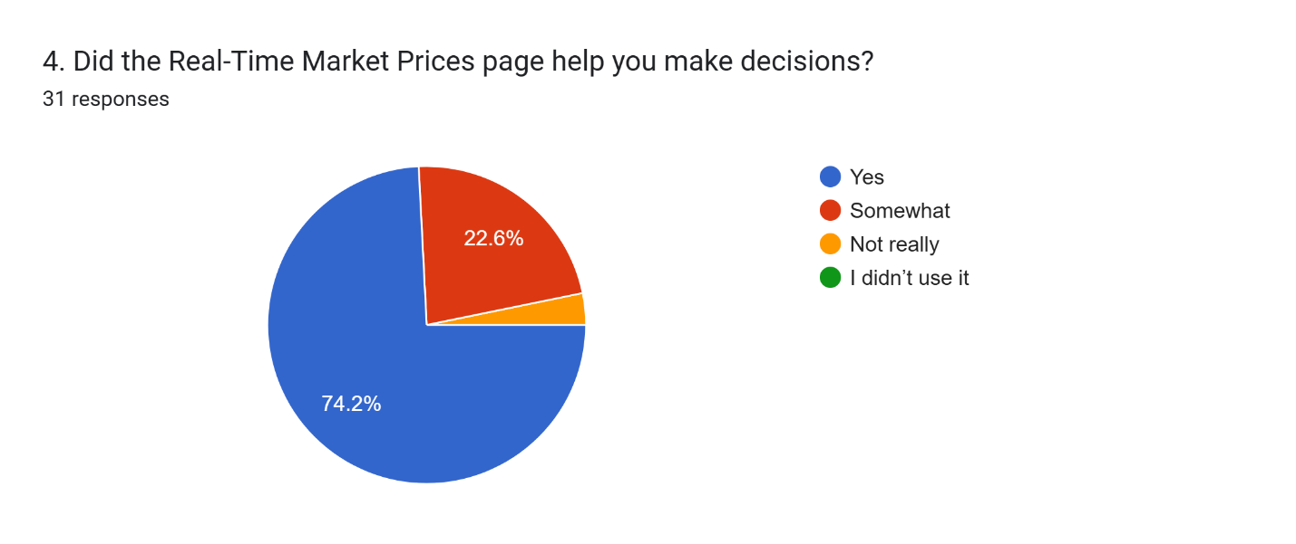

Figure 53 Questionnaire 4

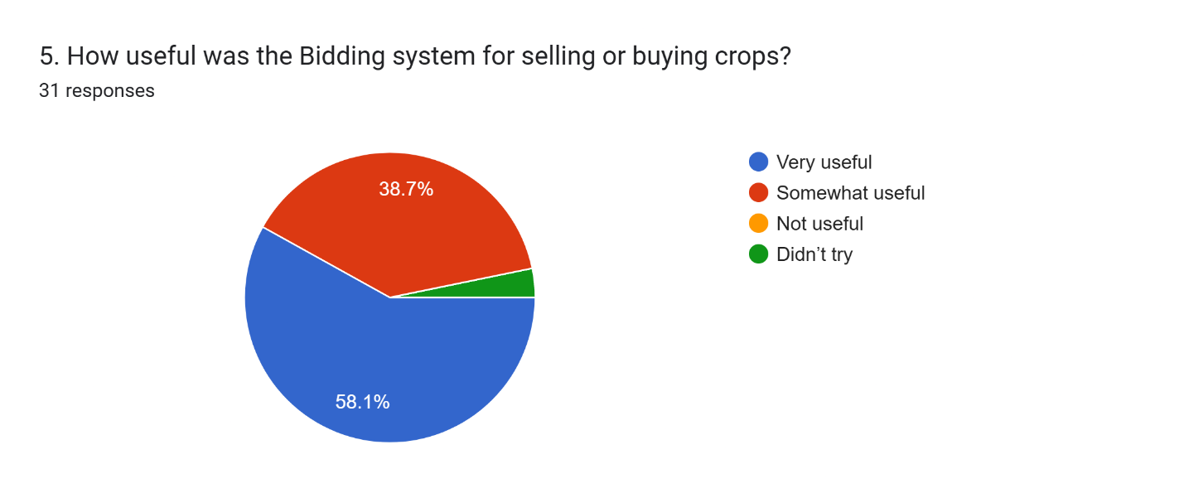

Figure 54 Questionnaire 5

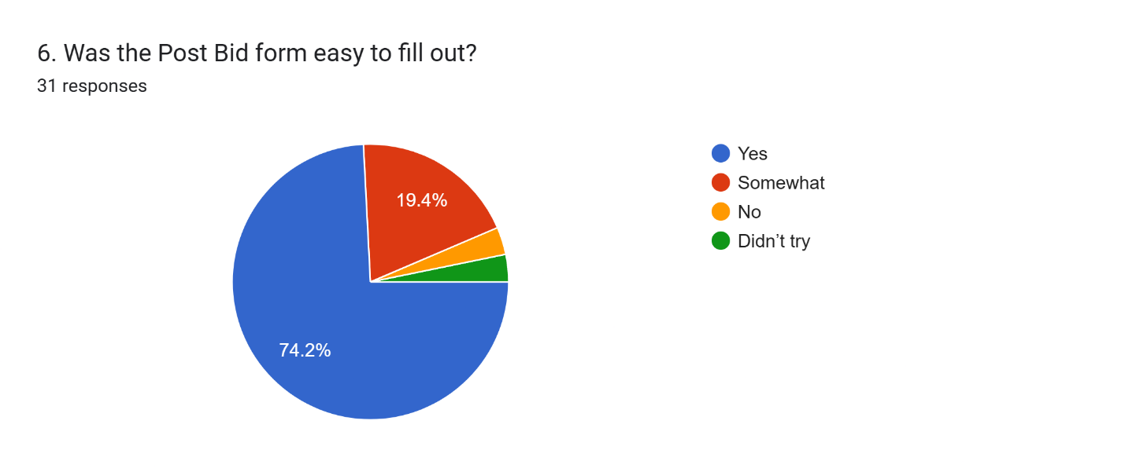

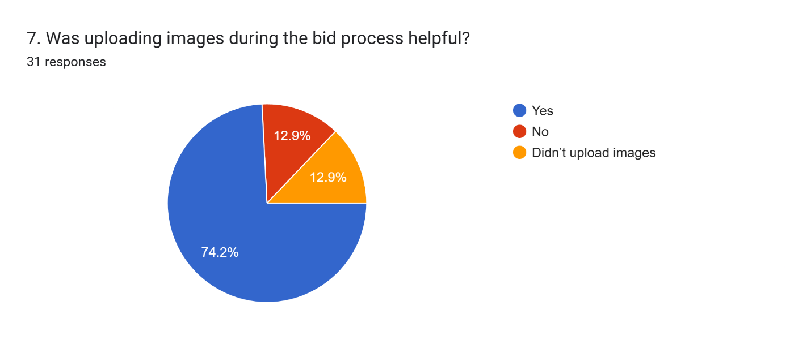

Figure 55 Questionnaire 7

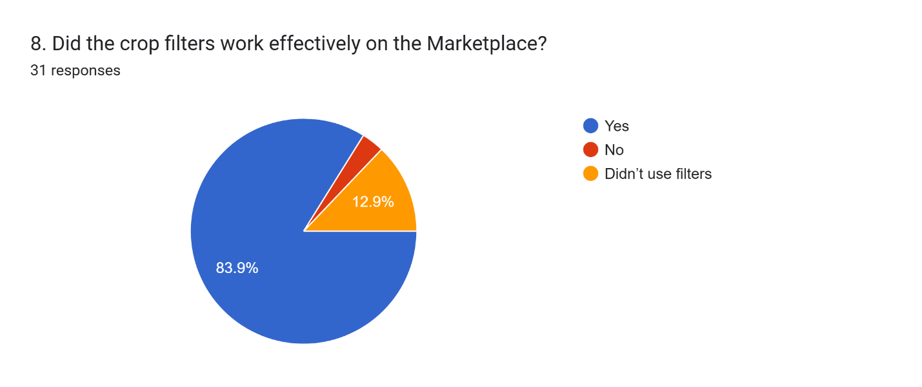

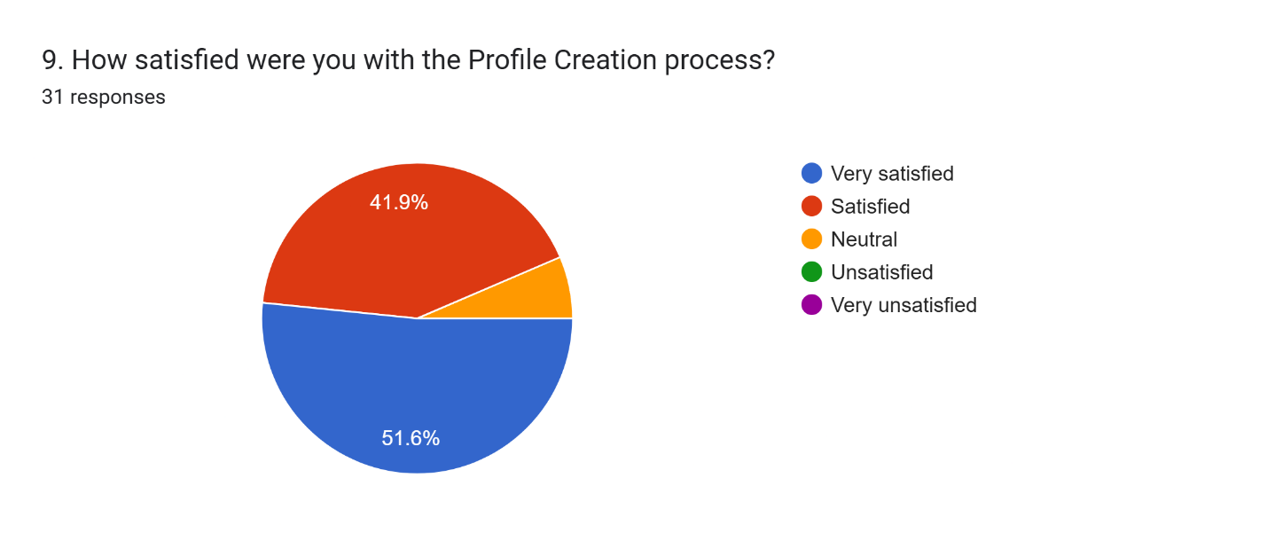

Figure 56 Questionnaire 9

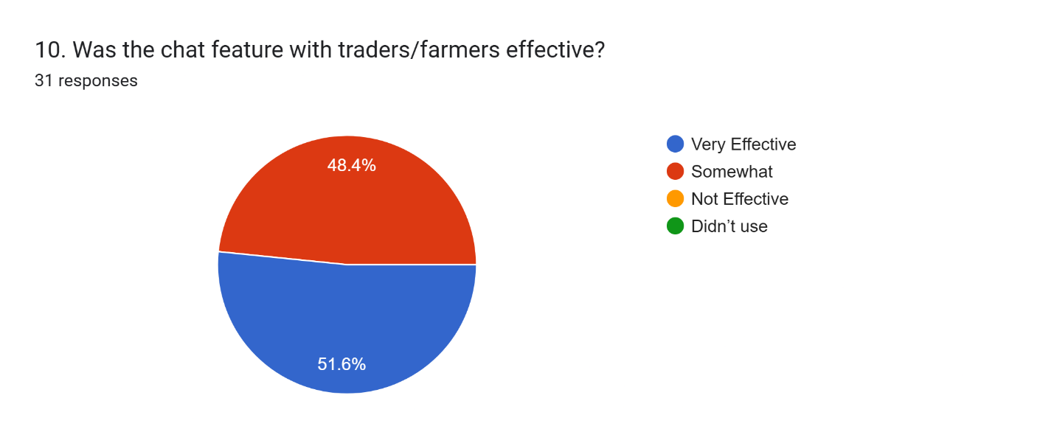

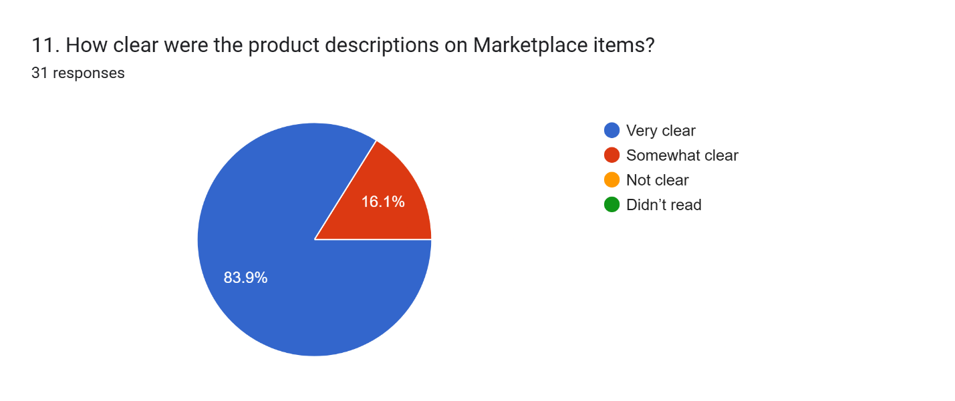

Figure 57 Questionnaire 11

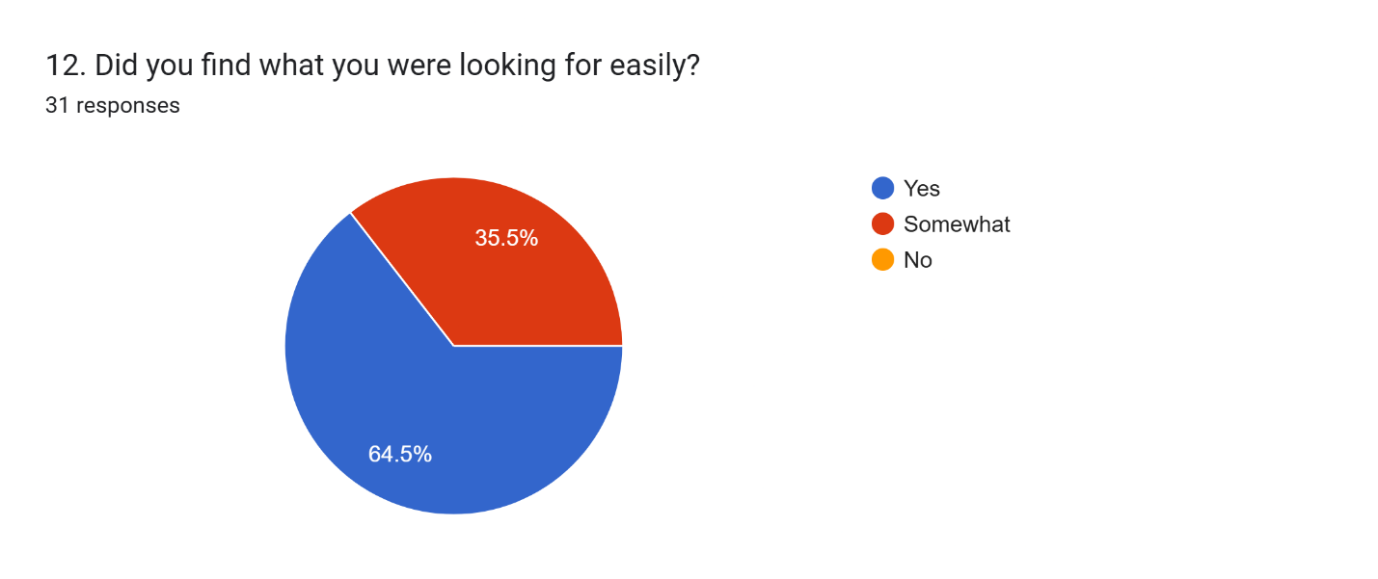

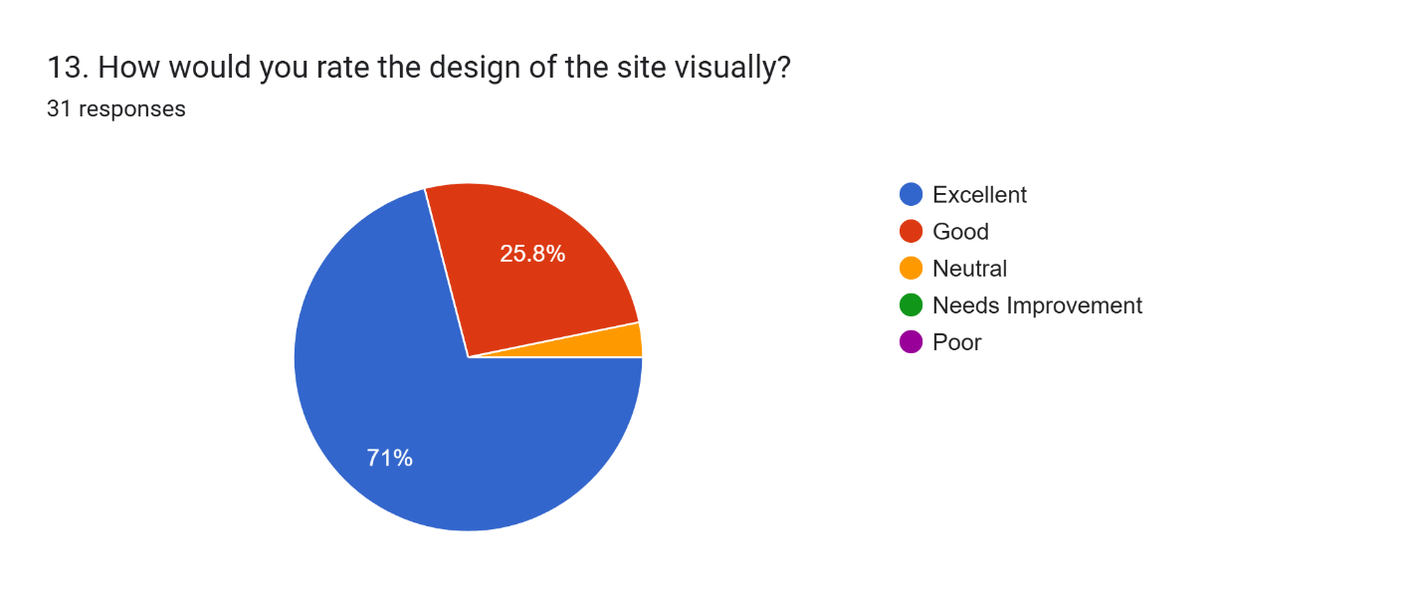

Figure 58 Questionnaire 13

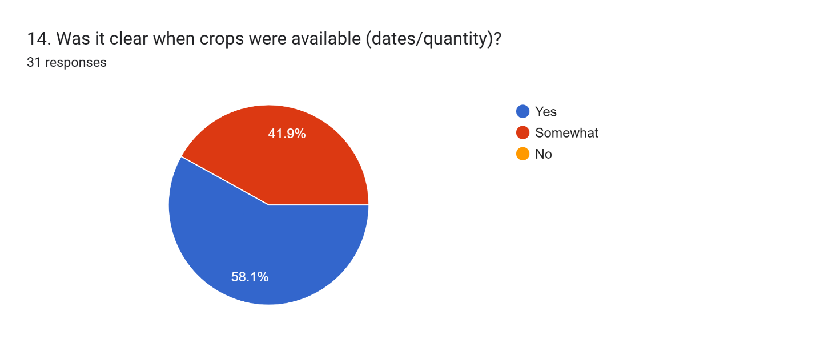

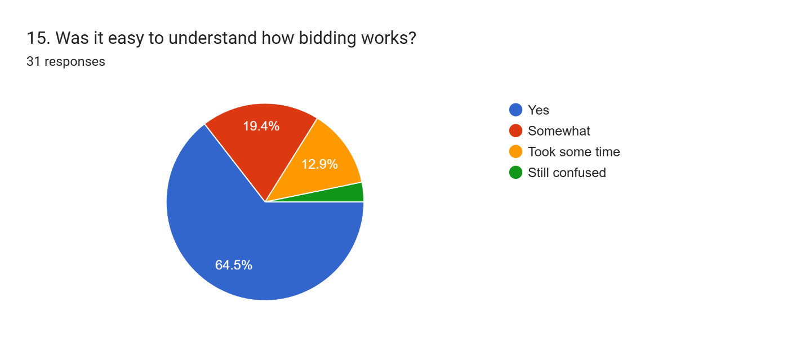

Figure 59 Questionnaire 15

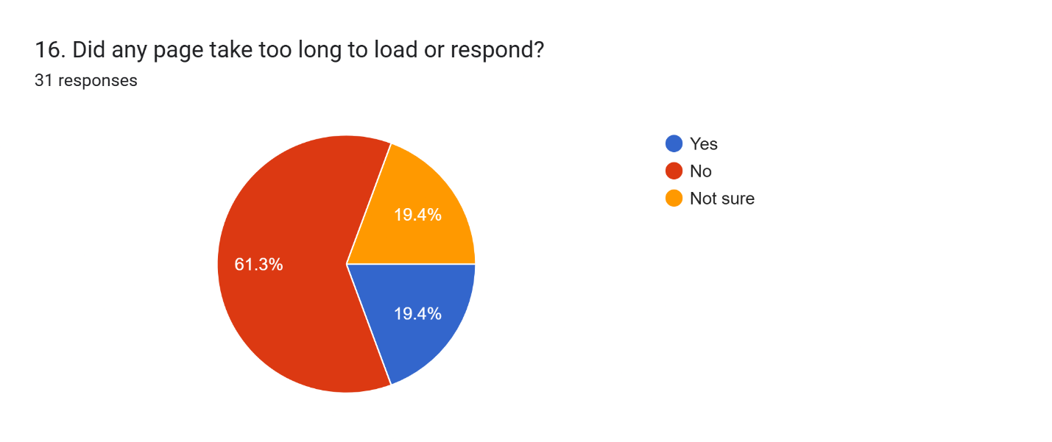

Figure 60 Questionnaire 17

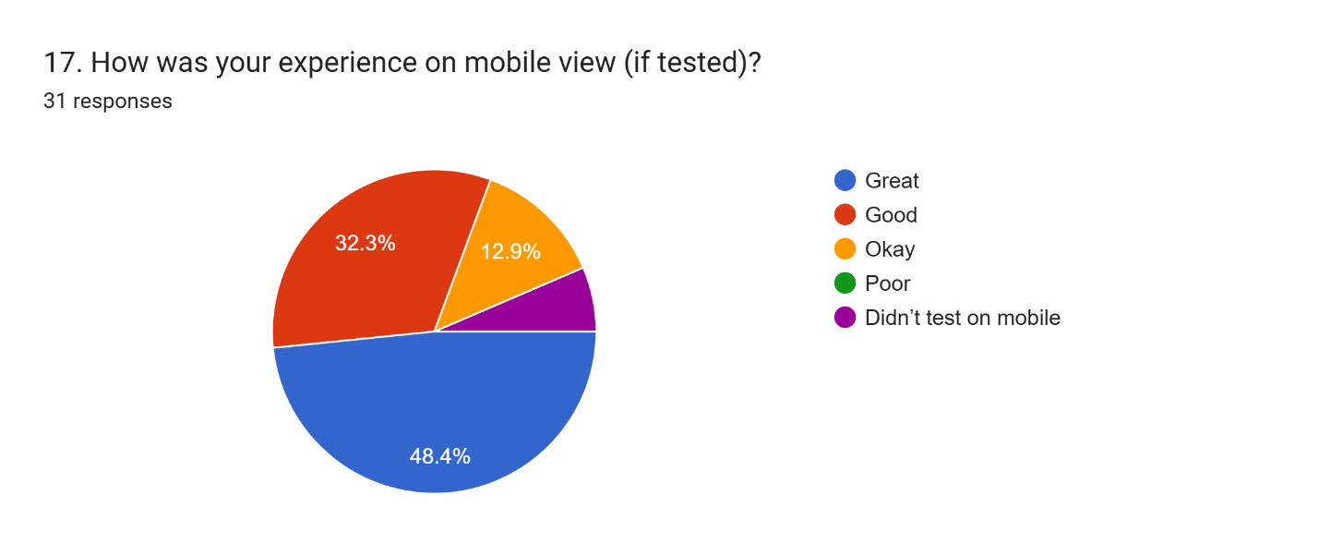

Figure 61 Questionnaire17

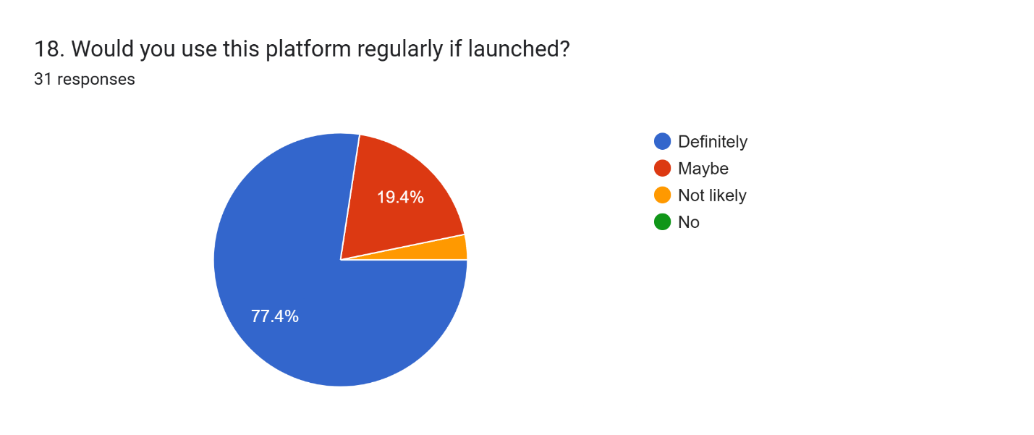

Figure 62 Questionnaire 18

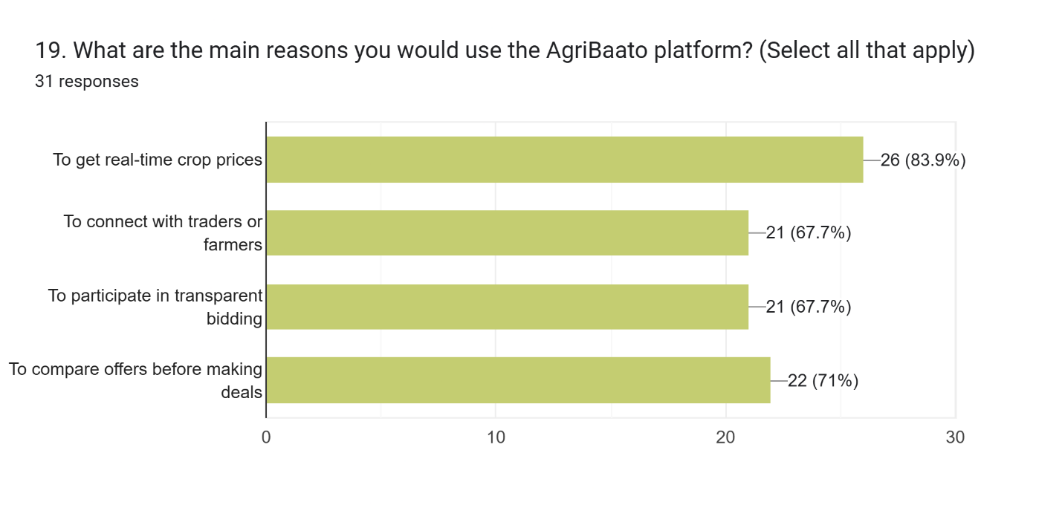

Figure 63 Questionnaire 19

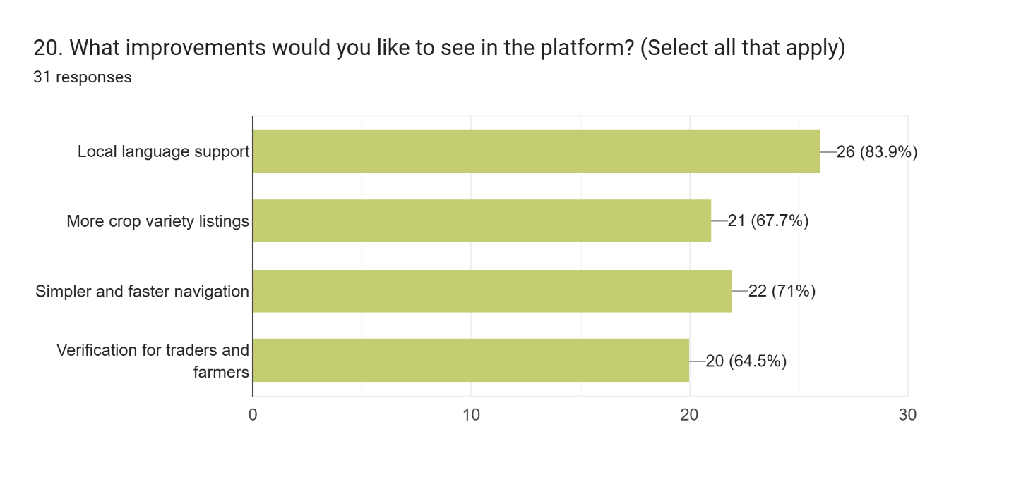

Figure 64 Questionnaire 20

# Conclusion

This project successfully met its goal of creating a user-centered digital platform, AgriBaato, to facilitate agricultural transactions in Nepal. The documentation covers the full design process, from topic selection and research to target audience identification, project objective definition, and product evaluation. It described the planning processes, which included creating a Gantt chart, identifying resources, and breaking down production. User personas, information architecture, wireframes, prototypes, branding, and color schemes were all extensively documented.

In addition, the project integrated a number of user-requested features, including real-time market prices, an interactive bidding mechanism, crop screening, and a dedicated marketplace. Usability testing and survey results were gathered to assess the design's effectiveness and clarity, which were then used to make additional improvements. The end result is a fully designed high-fidelity prototype that reflects the practical and aesthetic components of an efficient digital platform.

Overall, this paper provides a comprehensive and systematic account of how UX concepts were used to develop a meaningful and accessible solution for Nepal's agricultural community. Through easy design, efficient interaction, and compelling visual communication, the project successfully bridged the gap between farmers and dealers.

# References

Geokrishi.farm. (2020). *Geokrishi - Digitalizing Agriculture in Nepal*. [online] Available at: <https://geokrishi.farm/> [Accessed 7 May 2025].

AgriWebb. (n.d.). *AgriWebb | Livestock Farm Management Software*. [online] Available at: <https://www.agriwebb.com/>.

# Appendix

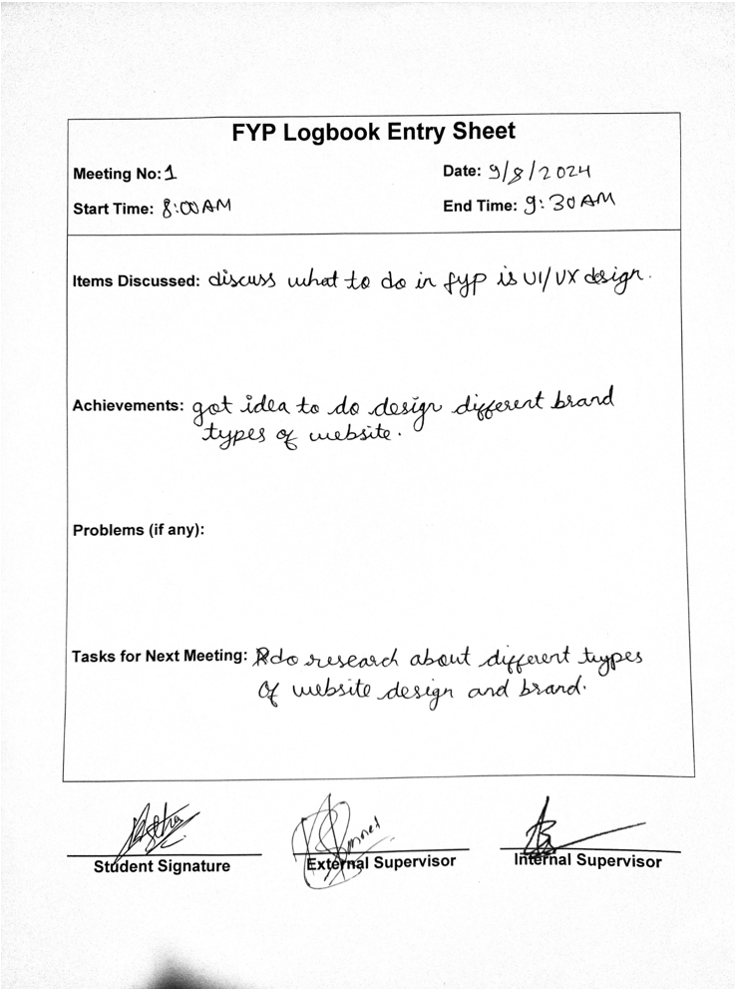

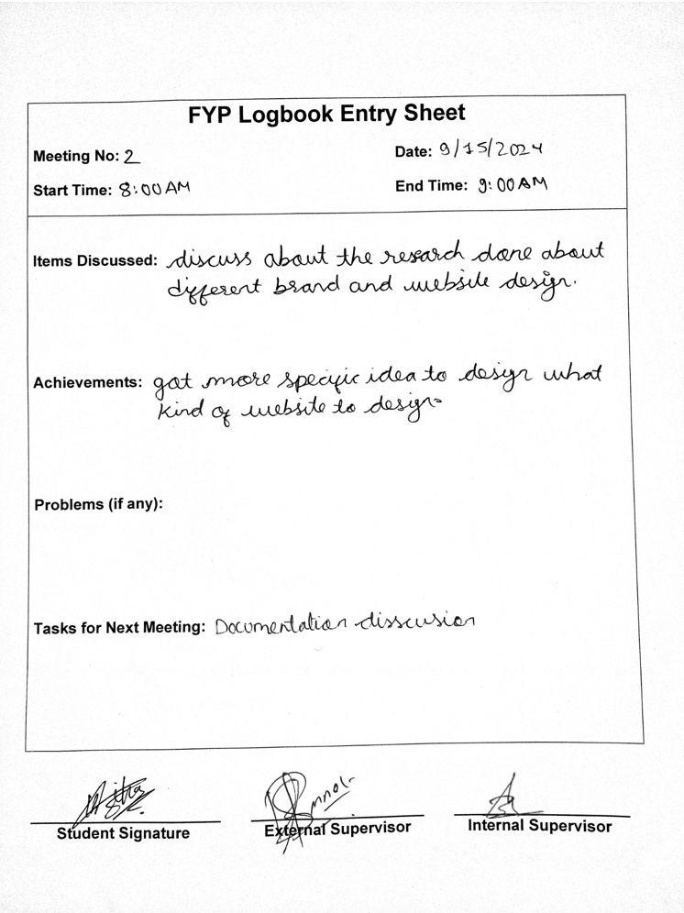

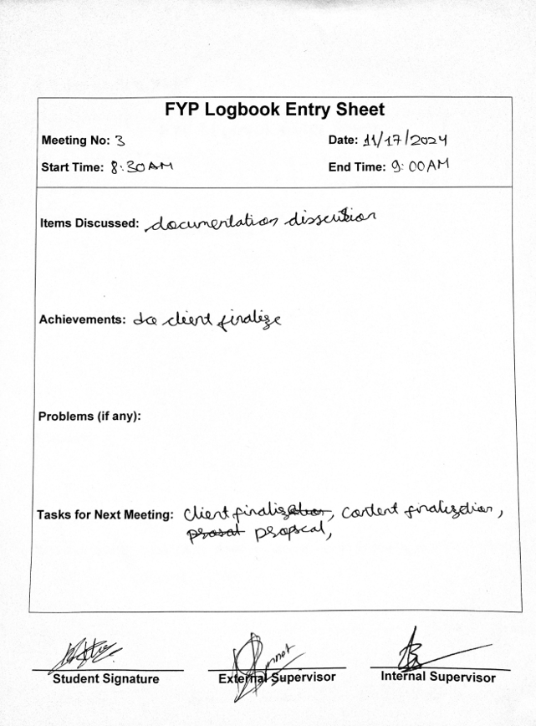

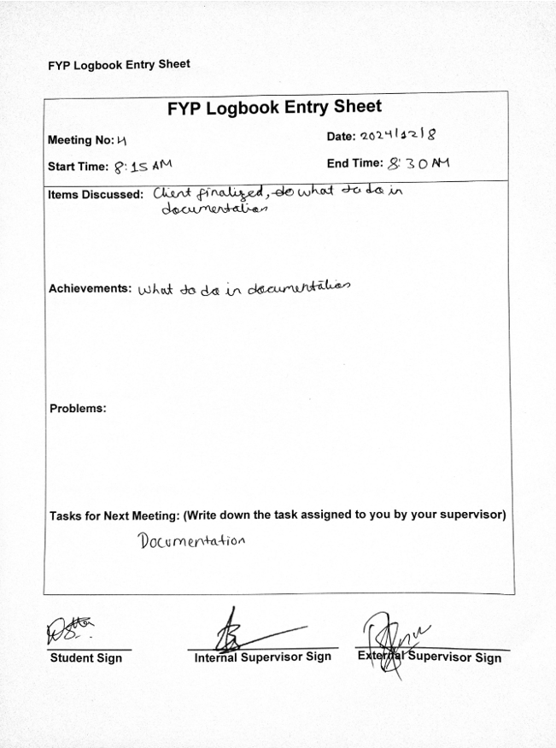

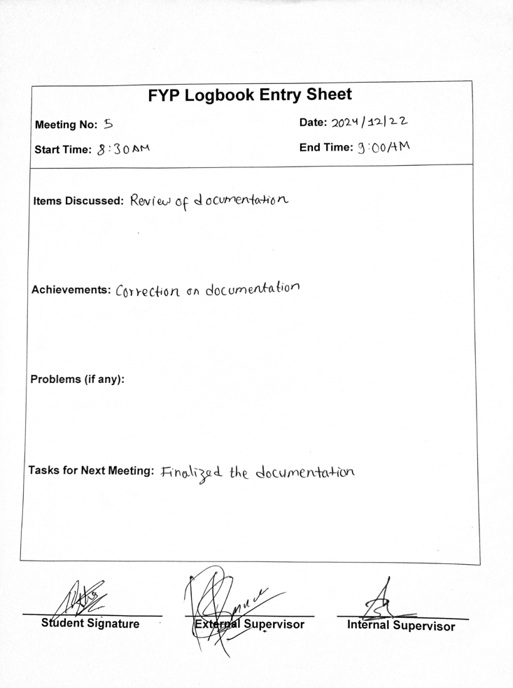

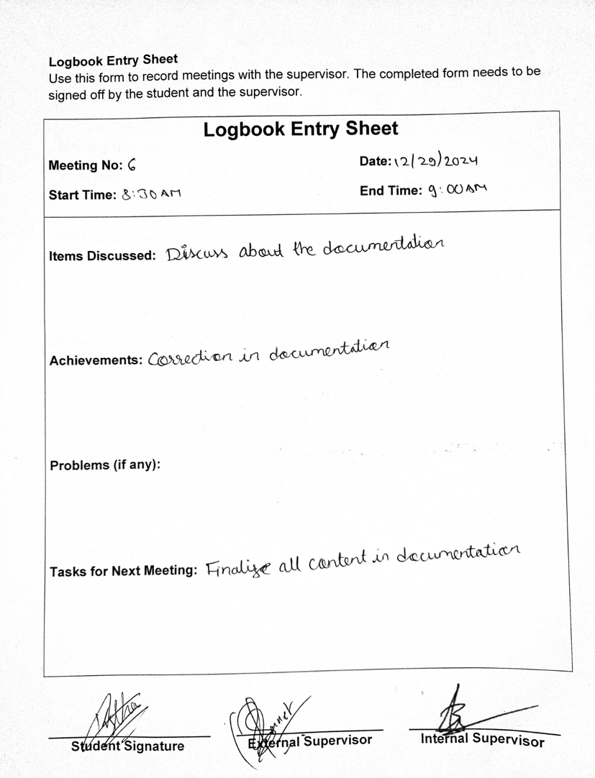

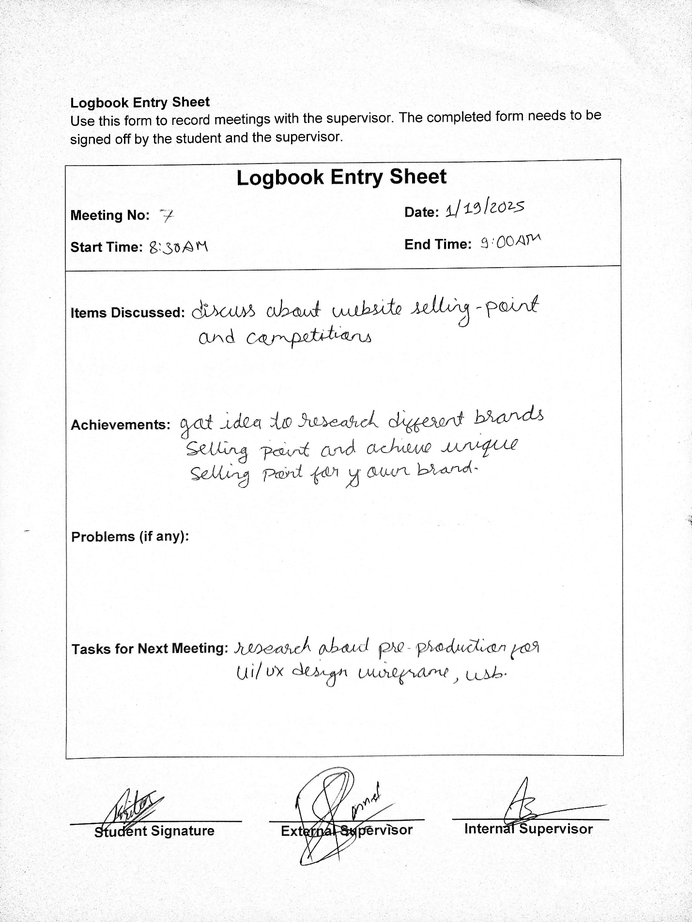

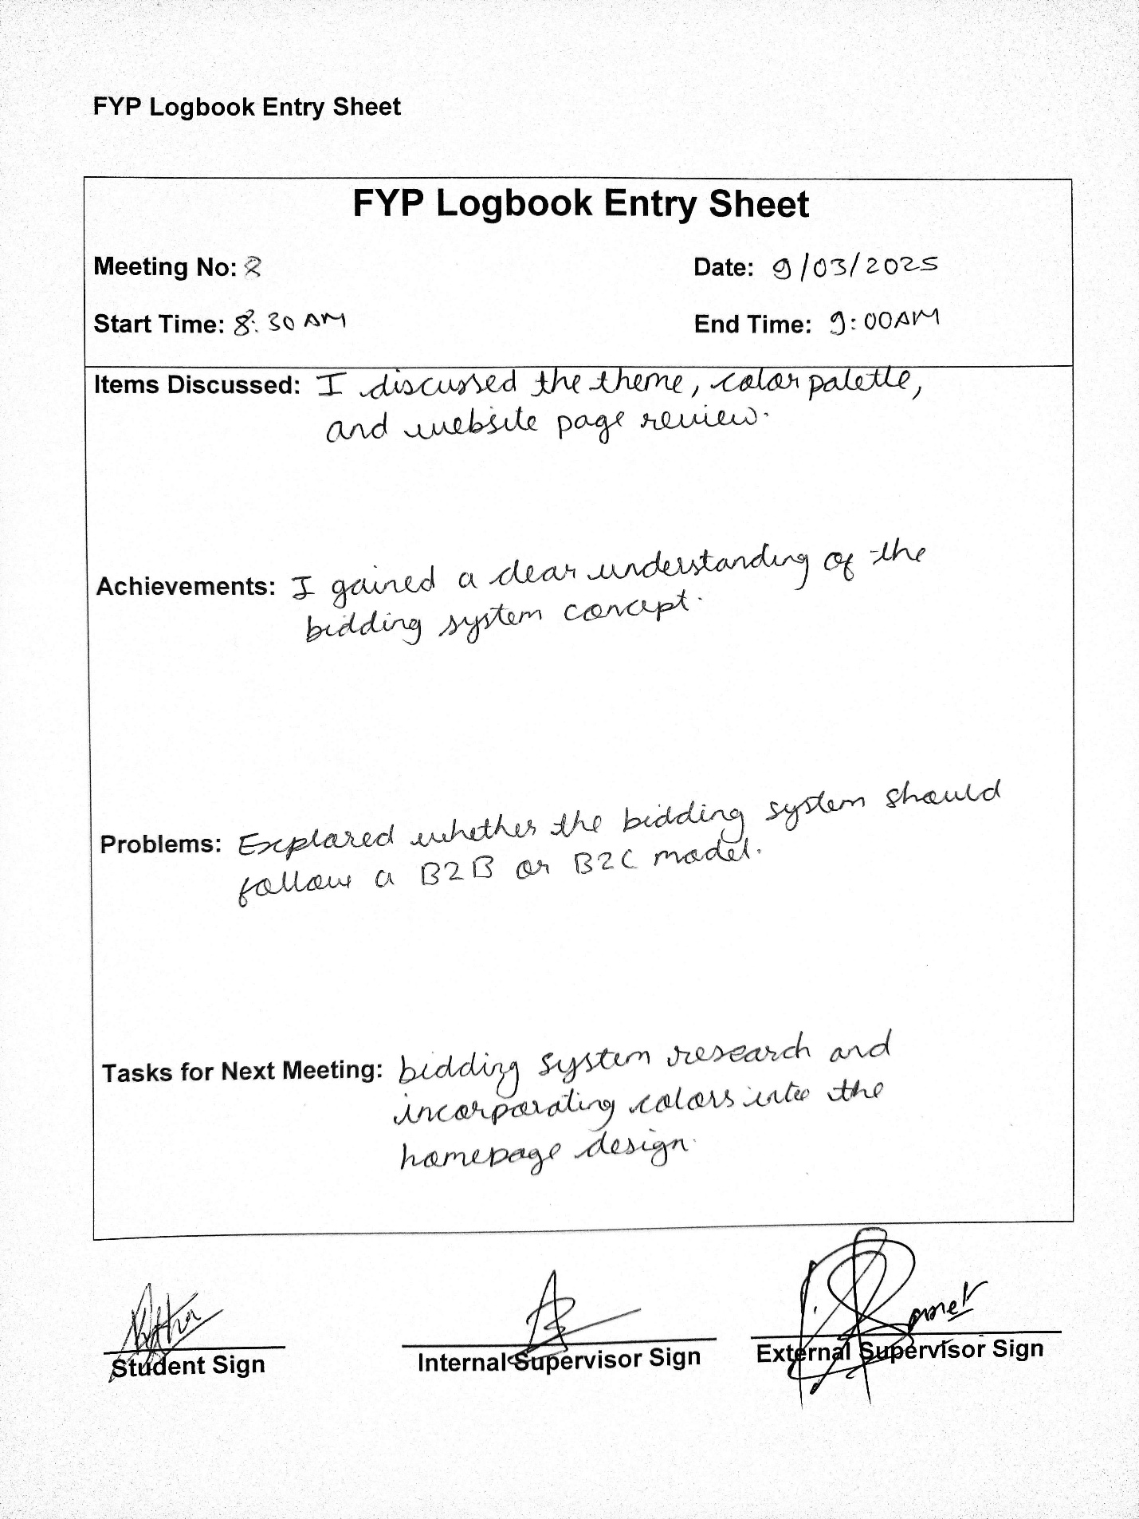

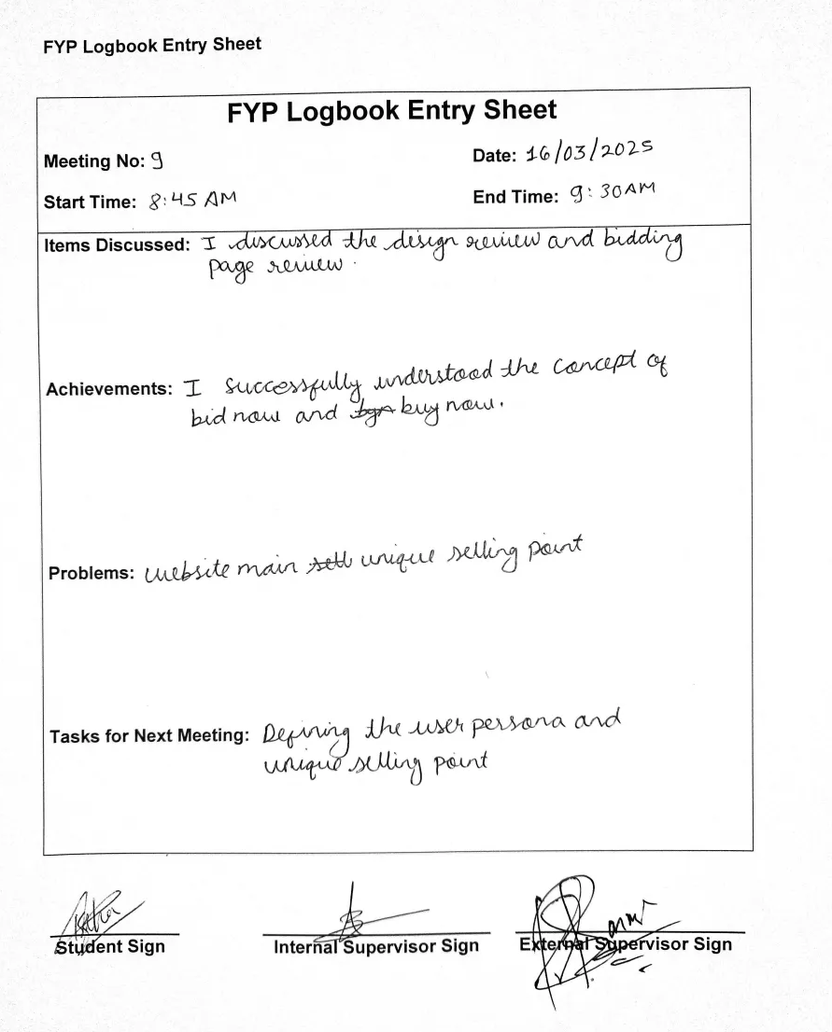

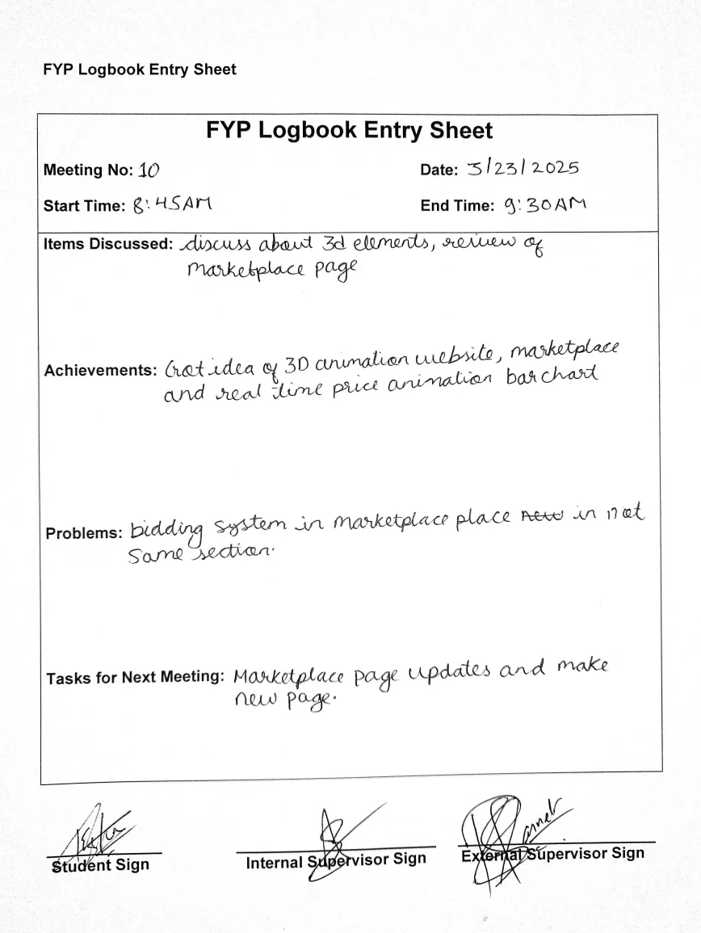

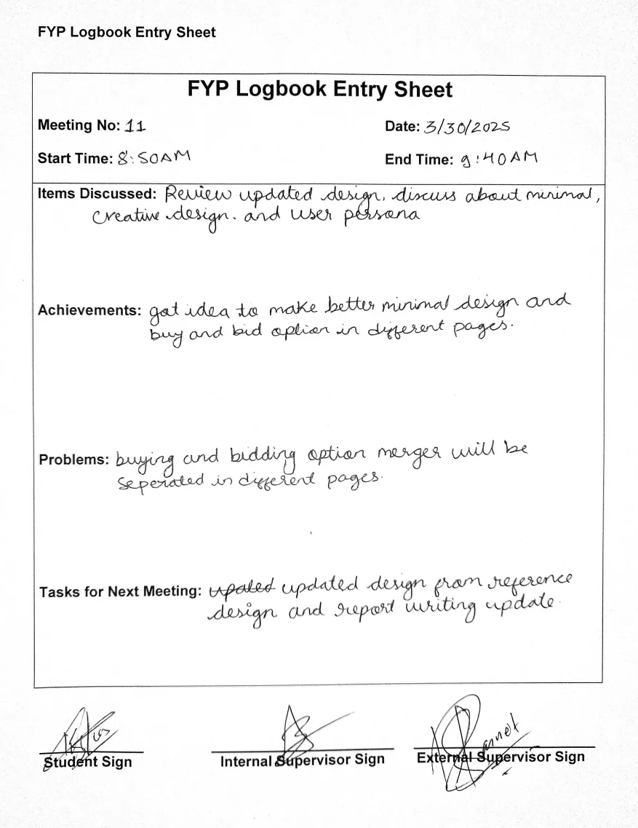

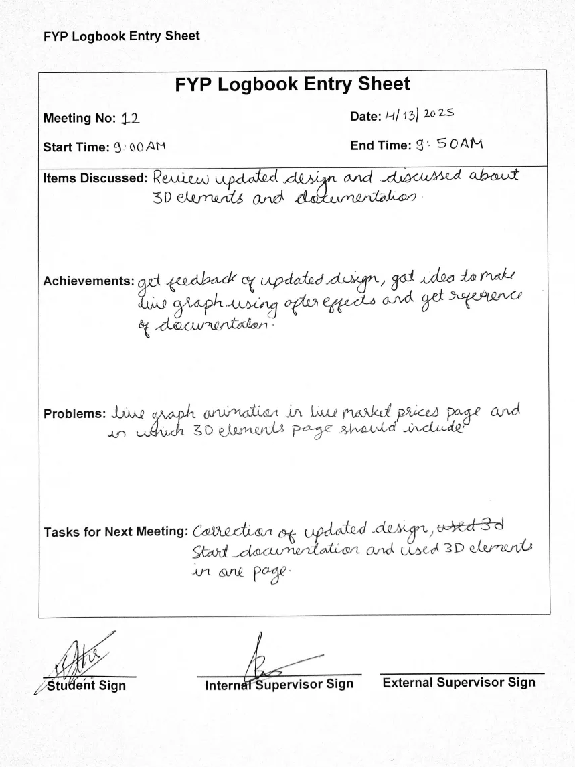

Gantt Chart

